TÜRKİYE PUBLIC AND MUNICIPAL RENEWABLE ENERGY PROJECT
(PUMREP)

436 kWp /360 kWe Solar Power Plant of
Kovancılar Municipality

STAKEHOLDER ENGAGEMENT PLAN(SEP)

July 2025

REVISION HISTORY
Version No | Version | Date of Issue | Prepared by | Submitted to
01 | Initial Draft | Mar 09,2025 | PVGLOBAL Energy | İLBANK
02 | Draft | Apr 16,2025 | PVGLOBAL Energy | İLBANK
03 | Draft | May 08,2025 | PVGLOBAL Energy | İLBANK
04 |  | July 21,2025 | PVGLOBAL Energy | İLBANK

Sub-Project Information
Sub-Project | Details
Name | KOVANCILAR Munıcıpalıty 436 kWp/360 kWe Solar Power Plant Project
Project Owner/ Sub-borrower | KOVANCILAR Munıcıpalıty
Financial Intermediary | İller Bankası A.Ş (ILBANK)
Prepared by | PVGLOBAL Energy

TABLE OF CONTENTS
TABLE OF CONTENTS i
LIST OF TABLES iii
LIST OF FIGURES iv
LIST OF ABBREVIATIONS v
EXECUTIVE SUMMARY 6
1. INTRODUCTION/PROJECT DESCRIPTION 8
1.1. Objectives 8
1.2. Components 8
1.3. Location 8
1.4. Area of Influence 11
2. OBJECTIVE/ DESCRIPTION OF SEP 13
3. STAKEHOLDER IDENTIFICATION AND ANALYSIS 14
3.1. Methodology 14
3.2. Affected parties and other interested parties 14
3.3. Disadvantaged/ vulnerable individuals or groups 15
4. STAKEHOLDER ENGAGEMENT PROGRAM 19
4.1. Summary of stakeholder engagement done during project preparation 19
4.2. Summary of project stakeholder needs and methods, tools, and techniques for stakeholder engagement 20
4.3. Stakeholder engagement plan 22
4.4. Reporting back to stakeholders 26
5. RESOURCES AND RESPONSIBILITIES FOR IMPLEMENTING STAKEHOLDER ENGAGEMENT ACTIVITIES 28
5.1. Project Implementation Unit (PIU) 28
5.2. Resources 28
5.3. Management functions and responsibilities 29
6. GRIEVANCE MECHANISM 31
6.1. Grievance Mechanism at National Level 31
6.2. Subproject Level Grievance Mechanism 32
6.3. Grievance Mechanism for Workers 35
6.4. Sensitive and Confidential Grievances 35
7. MONITORING AND REPORTING 37
7.1. Summary of how SEP implementation will be monitored and reported 37
7.2. Reporting back to stakeholder groups 37
ANNEXES 39
Annex-A 39
Annex-B 40
Annex-C 41
Annex-D 42
Annex-E 43
Annex-F 44
Annex-G 46
1. STAKEHOLDER CONSULTATION MEETING 47
1.1 Summary 47
1.2 Question & Answer Session 47
1.3 Conclusion 48
2. Participant List 49
3. APPENDICES 50
Annex 1: Stakeholder Consultation Meeting Photos 50
Annex 2 Newspaper Advertisements 51
Annex 3 Brochure Distribution at the for Invitation to Stakeholder Consultation Meeting 53
Annex 4 Stakeholder Consultation Meeting Brochure for the Sub-Project 54
Annex 5 Screenshot of Publishing of ESMP Checklist and SEP on Elazığ Municipality Web Page 55

LIST OF TABLES
Table 1.Location of Sub-project 9
Table 2.Vulnerable and disadvantaged groups in İsmetpaşa Neighborhood 17
Table 3.Influence/Interest Table for stakeholder prioritizatio 18
Table 4.Stakeholder Engagement Plan 23
Table 5.Responsibilities 29
Table 6.Reporting Process Requirements and Distribution of Roles 37

LIST OF FIGURES
Figure 1. Map of Sub-Project Area 9
Figure 2.Map of ETL Route 10
Figure 3.Subproject Sites Access Route 10
Figure 4.Sub-project Area of Influence 11
Figure 5.Sub-project Area of Influence 12
Figure 6.Organisational structure of PIU 28
Figure 7. Kovancılar Municipality Website Screenshots 34

LIST OF ABBREVIATIONS
AoI | Area of influence
CIMER  CLO | Presidency’s Communication Centre  Community Liaison Officers
DC | Distributing center
EIA | Environmental Impact Assessment
ESMP  ESMS | Environmental and Social Management Plan  Environmental and Social Management System
ESS  GBV | Environmental and Social Standard  Gender Based Violence
ETL | Energy Transmission
GM | Grievance Mechanism
GMCP | Grievance Mechanism Contact Personnel
IFC | International Finance Corporation
IFI | International Financial Institutions
ILBANK | Iller Bank Inc.
LMP | Labor Management Plan
MoEUCC | Ministry of Environment, Urbanization and Climate Change
NGO  OIP | Non-Governmental Organizations  Other Interested Parties
OHS | Occupational Health and Safety
PAP | Project Affected People
PIU | Project Implementation Unit
PUMREP | The Turkish Public and Municipal Renewable Energy Project
RE | Renewable Energy
SEA/SH | Sexual Exploitation and Abuse/Sexual Harassment
SEP  TurkStat | Stakeholder Engagement Plan  Turkish Statistical Institute
WB  YIMER | World Bank  Foreigners Communication Centre

EXECUTIVE SUMMARY
The Türkiye Public and Municipal Renewable Energy Project (PUMREP) aims to support the Government of Türkiye in expanding the use of renewable energy in the public sector, focusing on central government buildings and municipalities. The sub-project will contribute to the expansion of the Renewable Energy (RE) market in public facilities and take a leading role in the public sector in using sustainable energy solutions to meet the country's carbon emission reduction commitments and increase energy security. PUMREP will support the introduction of RE technologies in municipalities and will be implemented by İller Bankası A.Ş. (ILBANK). The sub-project aims to reduce the energy consumption cost of public facilities (administrative buildings, water promotion centers and water treatment plants, lighting).
ILBANK has established an Environmental and Social Management System (ESMS) that entered into force on December 24, 2023. The ESMS aims to systematically identify, assess, manage, monitor and report environmental and social (E&S) risks and impacts of projects and sub-projects financed by International Financial Institutions (IFIs). This process should be implemented continuously throughout the loan period in line with the requirements of national legislation, international agreements and conventions ratified by Türkiye, and the E&S standards of the lending IFIs (World Bank for PUMREP). As a critical element of the ESMS, ILBANK has adopted and published an E&S Policy that applies to all ILBANK projects and sub-projects financed through IFIs.
The subproject involves the construction of a solar power plant (SPP) to be implemented by Kovancılar Municipality on lots 3766 of block 0, İsmetpaşa Neighborhood, Kovancılar district, Elazığ province. . The activities of the mentioned subprojects will be realized in an area of 9.154 m². The ownership of the parcels subject to the sub-project belongs to Kovancılar Municipality.
The subproject is classified as Moderate Risk Category in accordance with ILBANK ESMS and World Bank Environmental and Social Framework (WBS ESF), 2018. One of the tasks within the scope of the subproject is to prepare a Stakeholder Engagement Plan (SEP) in accordance with ILBANK ESMS, WBS ESF and national legislation in force in Türkiye.
Therefore, this Stakeholder Engagement Plan (SEP) has been prepared to identify all stakeholders, inform them about the sub-project and its potential environmental and social risks and impacts and their interest in the sub-project, and define the procedures and principles to establish effective communication with stakeholders and increase participation. This Plan aims to establish long-term relationships based on mutual trust and transparency between the sub-project and local communities. In addition, it is aimed to reduce the negative impacts that may arise from the sub-project and increase the positive impacts. With the implementation of this SEP, stakeholders will be able to access information about the sub-project, its investments, installation works and operational activities in a timely manner.

This plan includes the legal framework, the process of identifying stakeholders, and the description of the stakeholder engagement program (including the purpose and timing, the proposed strategy for information sharing, the proposed strategy for consultation, future engagement activities, the grievance mechanism covering the receipt and closure of all grievances, the necessary measures to be taken and the management of grievances). In addition, specific engagement and information activities targeting vulnerable groups/individuals identified within the scope of the SEP have been defined.
A Stakeholder Engagement Plan is a component of the subproject management plan that defines the strategies and actions needed to promote effective stakeholder participation in project or program decision-making and execution.
Planning Stakeholder Engagement:
- Provides a clear and actionable plan to be used in engaging with subproject stakeholders to realize the subproject's objectives.
- Documents how the sub-borrower will interact with identified stakeholders throughout the life of the subproject.
- It defines the management strategies necessary to effectively engage stakeholders in the subproject..

INTRODUCTION/PROJECT DESCRIPTION

Objectives
The Public and Municipal Renewable Energy Project (PUMREP) (hereinafter the “Project”) aims to support the Government of Türkiye to scale-up Renewable Energy (RE) use in the public sector by focusing on central government buildings and municipalities. The sub-project involves the establishment and operation of "Kovancılar Municipality 436 kWp/360 kWp Solar Power Plant, located within the borders of İsmetpaşa neighborhood in the Kovancılar district of Elazığ province. The Project is financed by World Bank (WB) to support introducing RE technologies in municipalities. İller Bankası A.Ş. (ILBANK) acts as the Financial Intermediary (FI). The RE installations will be primarily used to offset the overall energy consumption from public facilities (i.e. administrative buildings, water supply and water treatment, public lighting, etc.) and thus reduce the municipalities’ energy bills.
This document is prepared in accordance with Environmental and Social Standard (ESS) 10 on Stakeholder Engagement and Information Disclosure, as part of the Environmental and Social Framework (ESF). Kovancılar Municipality is responsible for stakeholder engagement activities and grievance resolution, ensuring that the subproject is carried out in an inclusive and participatory manner.

Components
The sub-project includes the installation of solar power plants (SPP) .The Energy Transmission Line (ETL) will carry the Direct Current (DC) output from the SPP via an underground cable route of approximately 160 meters along Kanalyurt Street and connect to the existing TOKİ transformer center (see Figure 2).
The sub-project site is located approximately 500 meters from the Tunceli Highway. Site access will be provided via Kanalyurt Street, which branches off from the highway. No new access road will be constructed as part of the subproject. Kanalyurt Street, which consists of both asphalt and paving stone surfaces, is approximately 10 meters wide and provides direct access to the project site (see Figure 3).

Location
The Kovancılar Municipality 436 kWp / 360 kWe Solar Power Plant Project is planned to be implemented on Lot 3766, Block 0, located in the İsmetpaşa Neighborhood of Kovancılar District, Elazığ Province. The designated parcel has a total area of 9,154 m², and all subproject activities will be carried out entirely within this area. The ownership of the parcels subject to the sub-project belongs to Kovancılar Municipality. The parcel is designated as land plot in the land registry. The location of the sub-project on the map is given in the figure (See Figure 1).

Table 1. Location of Sub-project

Information | Remarks/ Notes
Province | Elazığ
District | Kovancılar
Neighborhood/ Village | İsmetpaşa
Block/Lot | Lot 3766 of block 0
Land Area (ha) | 0.9 ha
Land Use Type according to Title Deed | Irrigated Field
Current Land Use | There is no agriculture, animal husbandry or commercial activity.
Other Nearby Facilities and Activities | There is no Associated Facility (AF) within the scope of the Sub-Project. There is no agricultural, animal husbandry or commercial activity in the sub-project area. However, there is a Septi Girls' Education Course 70 meters away, which is likely to be affected by sub-project activities (traffic, noise, dust emissions, etc.).

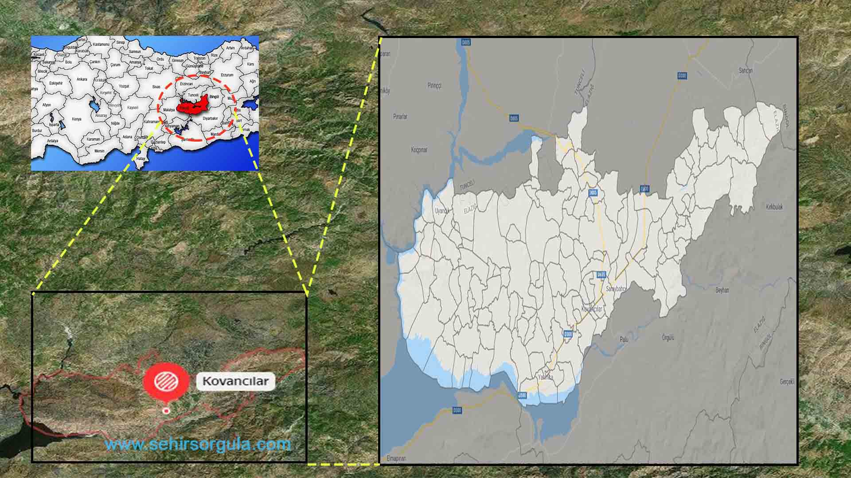
Figure 1. Map of Sub-Project Area

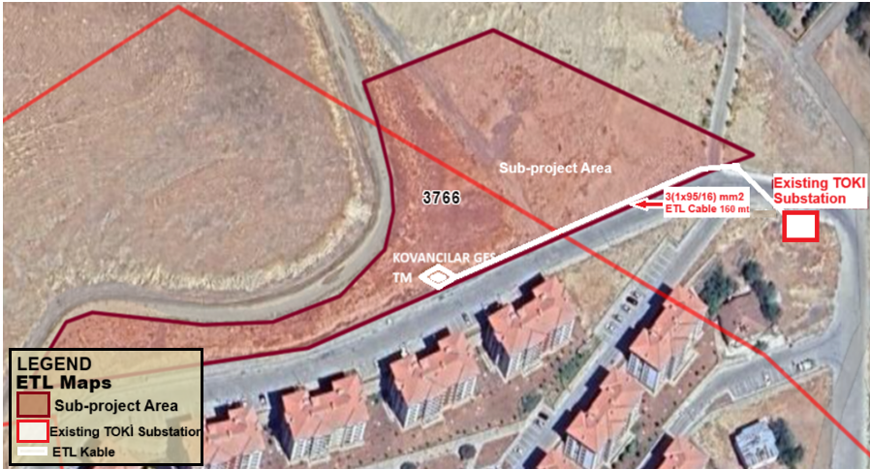
Figure 2.Map of ETL Route
The sub-project area is 500 meters away from the Tunceli highway and access to the site will be provided by this road (See Figure 3). Access to the sub-project area will be provided by Kanalyurt Street after exiting the Tunceli highway and no new road will be built. Kanalyurt Street, which is asphalt and approximately 10 meters wide, extends to the sub-project area. Roads in densely populated residential areas will not be used for access to the site.
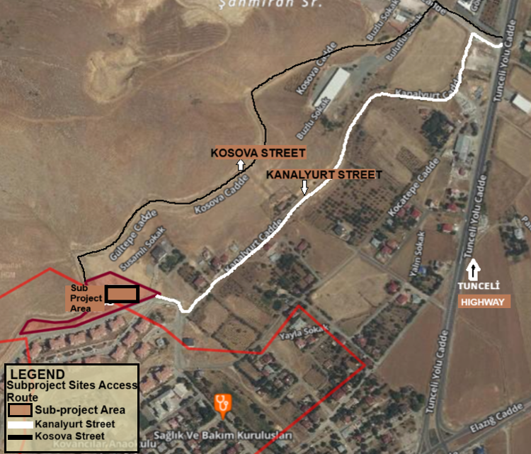
Figure 3. Subproject Sites Access Route

Area of Influence
According to WB ESS1, “where the project involves specifically identified physical elements, matters and facilities that are likely to create impacts, environmental and social risks and impacts shall be identified in the context of the sub project's Area of influence (AoI)”. Thus, AoI of the subproject consists of urban or rural areas likely to be affected by the project, its activities and facilities that are directly owned, operated, or managed (including by contractors). The subproject AoI consists of environmental and social aspects including: the subproject site, surrounding residential areas subproject access roads and ETL routes. Environmental and social impacts caused by the subproject have been taken into consideration to determine the AoI from the sub project area. Therefore, as a precautionary measure, 100 meters of the sub-project site and 100 meters around the areas where the power line passes have been determined as the impact area. The residences and sensitive receptors within the sub-project impact area are shown in the figure below (See Figure 4 and Figure 5). Septi Girls Training Field is located 70 meters away from the sub-project area. Also, there are TOKİ residential houses and İsmetpaşa neighborhood houses 50 meters away within the sub-project impact area. There is a possibility of being affected by sub-project activities (traffic, noise, dust emission, etc.).
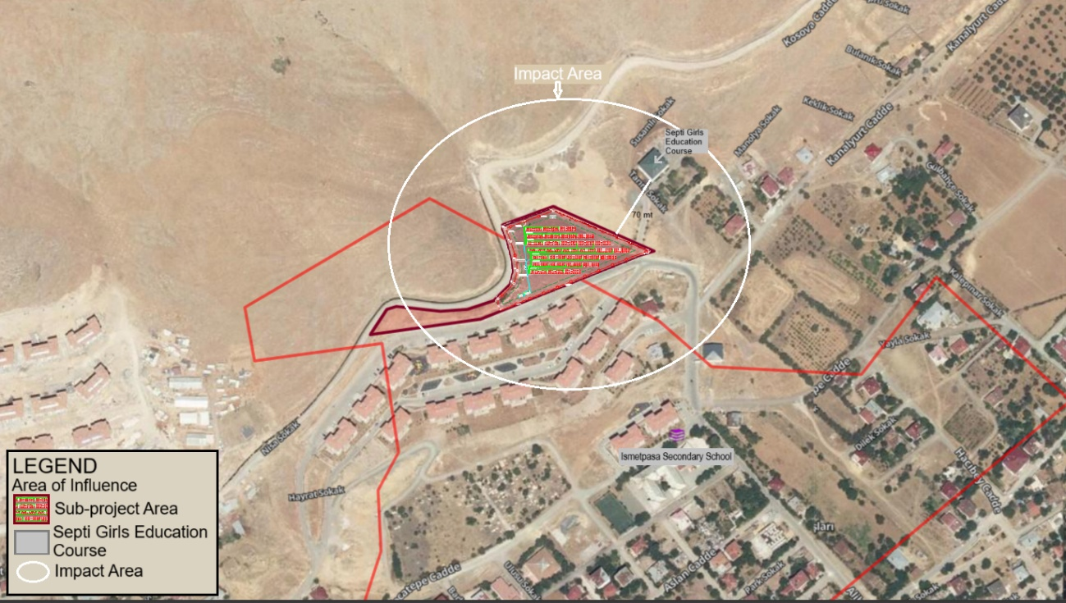
Figure 4.Sub-project Area of Influence
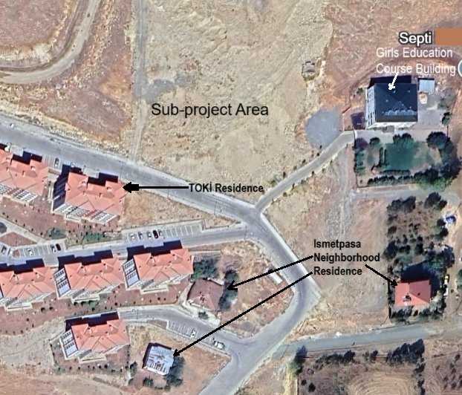
Figure 5.Sub-project Area of Influence

OBJECTIVE/ DESCRIPTION OF SEP
This SEP, prepared within the scope of the World Bank's Environmental and Social Standard No. 10, Stakeholder Engagement and Disclosure of Information, provides a framework to support the establishment of a seamless engagement process among stakeholders who are likely to be affected by or interested in the subproject. The document also contributes to managing stakeholder expectations and supporting risk management by providing early, frequent and open communication throughout the project lifecycle.
The main objectives of this SEP are presented below;
• Identify stakeholders affected by the project and establish and maintain constructive relationships with all identified stakeholders.
• Establish and promote effective and inclusive relationships with project affected parties throughout the project life cycle.
• Ensuring that project information is publicised in a timely, understandable and accessible manner.
• Providing means for the parties affected by the project to express their opinions, suggestions and complaints.

STAKEHOLDER IDENTIFICATION AND ANALYSIS

3.1. Methodology
In order to meet best practice approaches, the project will apply the following principles for stakeholder engagement;
- Openness and life cycle approach: The public consultation process for the project should be organized throughout the entire life cycle, conducted in an open manner, without external manipulation, interference, coercion or intimidation;
- Informed participation and feedback: Information will be provided to all stakeholders in an appropriate format and widely disseminated, providing opportunities for stakeholders to provide feedback, analyze and address comments and concerns;
- Inclusion and sensitivity: Stakeholder identification is done to support better communication and build effective relationships. The process of participation in projects is inclusive. All stakeholders are encouraged to participate in the consultation process as circumstances allow. Access to information is provided to all stakeholders on an equal basis. Sensitivity to stakeholders’ needs is the key principle underlying the selection of engagement methods. Special attention is given to vulnerable groups that may be at risk of being left out of project benefits, particularly women, the elderly, persons with disabilities, displaced persons, and migrant workers and communities, and the cultural sensitivities of diverse ethnic groups.
- Flexibility: If social distancing, cultural context (for example, particular gender dynamics), or governance factors (for example, high risk of retaliation) inhibits traditional forms of face-to-face engagement, the methodology should adapt to other forms of engagement, including various forms of internet- or phone-based communication.
For the subproject, the following stakeholders have been identified and analyzed per project component. These stakeholders include affected parties, other interested parties and disadvantaged/vulnerable individuals or groups.

3.2. Affected parties and other interested parties
The term "project-affected parties" refers to individuals or groups who are likely to be affected by the sub-project due to direct impacts or potential risks on their physical environment, health, safety, cultural practices. Specifically, the following individuals and groups fall within this category:
• Residents of İsmetpaşa Neighbourhood
• Persons who will work within the scope of the subproject
• Educational institution near the sub-project area (Septi Girls Education Course)
Within the scope of SEP, on April 22, 2025, on-site inspections were carried out by the consultant company manager and social expert and consultations were made with the İsmetpaşa neighborhood mukhtar and İsmetpaşa neighborhood residents. A meeting was held with the parents of a Septi Girls Education Course student. Consultations were held with households living in TOKİ houses close to the Sub-Project area. Sensitive individuals who may be negatively affected by the sub-project activities were investigated. İsmetpaşa neighborhood residents and individuals in the Septi Girls Education Course were asked about their information about the sub-project. Consultations were held regarding submitting their complaints and suggestions.
According TurkSTAT 2024 data, the population of İsmetpaşa neighborhood is 2,018 people. 1,007 of this population are male and 1,011 are female (TurkSTAT 2024).
Other Interested Parties are individuals or groups that are not directly involved in the project, but may nevertheless have an interest in project outputs, decisions or activities. A list of this stakeholder group is presented below:
• Residents outside the sub-project area in Kovancılar district,
• Ministry of Industry and Technology
• Ministry of Energy and Natural Resources
• Ministry of Environment, Urbanisation and Climate Change
• Elazığ Provincial Directorate of Environment, Urbanisation and Climate Change
• Elazığ Provincial Directorate of Industry and Technology
• Elazığ Governorship
• Kovancılar District Governorship
• Kovancılar Food, Agriculture and Livestock District Directorate,
• Kovancilar Municipality Culture and Social Affairs Directorate
• Kovancılar Social Assistance and Solidarity Foundation Presidency
• Kovancılar Ajans
• Local Television Channels and Newspapers

3.3. Disadvantaged/ vulnerable individuals or groups
Disadvantaged/Vulnerable individuals or groups are persons who may be disproportionately impacted or further disadvantaged by the project(s) compared with any other groups due to their vulnerable status, and that may require special engagement efforts to ensure their equal representation in the consultation and decision-making process associated with the project.
During the construction phase of the subproject, dust or vehicle exhaust emissions or noise may cause adverse problems for vulnerable and disadvantaged individuals.
Specifically identified disadvantaged/vulnerable groups and the impacts that these groups are likely to face under the Sub-Project are given below;
- Illiterate individuals who never attended school:
Field data indicates that there are 15 individuals in the neighbourhood who never attended school and are illiterate. These individuals may experience difficulties in accessing written information materials and understanding consultation-related announcements.
- Mentally or Physically Disabled :
A total of 10 individuals with physical or mental disabilities live in the neighbourhood. These persons may have difficulties participating in meetings due to mobility or communication barriers. Caregivers may also face challenges attending events if they cannot leave those under their care.
- Households where the head of the household is a woman or a child:
According to the neighbourhood mukhtar, there are 4 households where the head is a woman or a child. These households may face challenges in participating in engagement activities due to caregiving responsibilities and household burdens.
- Surviving on social assistance from the state, associations or individuals:
140 individuals in the neighbourhood benefit from social assistance provided by the state, associations, or individuals. Their financial difficulties may limit their access to transportation or digital platforms where information is shared.
- Households with low or no income, Unemployed people who cannot find a job:
There are 160 individuals in the neighbourhood who are unemployed or have no regular income. These individuals may prioritize job-seeking activities over participation in consultation meetings and may lack access to transportation or technology.
- Refugee or immigrant households:
There are 2 refugee or immigrant households residing in the neighbourhood. These households may face language barriers or feel socially excluded, making it harder for them to engage in project activities.
- Persons with chronic diseases requiring continuous medical intervention or persons in need of care :
Field observations show that 5 individuals require continuous medical intervention or assistance due to chronic illnesses. Their health conditions may prevent them from leaving their homes and attending meetings.
- Educational institution close to the sub-project area (Septi Girls Education Course):
Construction-related activities may disrupt the daily routines and access to basic services of teachers and students of Septi Girls Education Course within the impact area. It may potentially cause anxiety, fear and worry. They may be subject to sexual harassment. There are 46 individuals in total in Septi Girls Education Course, including 3 teachers, 1 officer and 42 female students.
Details of Vulnerable and Disadvantage Groups according to the information obtained from the mukhtar of İsmetpaşa neighborhood, the closest settlement to the sub-project site, are given in table (See Table 2).
Table 2. Vulnerable and disadvantaged groups in İsmetpaşa Neighborhood
Vulnerable and Disadvantage Groups | Number of People
Illiterate individuals who never attended school | 15
Mentally or Physically Disabled | 10
Households where the head of the household is a woman or a child | 4
Surviving on social assistance from the state, associations or individuals | 140
Households with low or no income, Unemployed people who cannot find a job | 160
Refugee or Immigrant | 2
Persons with chronic diseases requiring continuous medical intervention or persons in need of care | 5
Educational institution close to the sub-project area (Septi Girls Education Course) | 46
Total Vulnerable and Disadvantage Groups | 382
Source: Mukhtar Meetings, 2025.

Table 3. Influence/Interest Table for stakeholder prioritizatio
Stakeholder Groups |  |  | Level of Interest | Level of Impact
Project Affected Parties | Workforce | -Workers to be employed during the construction phase (including subcontractors and third parties workers) | High | High
Project Affected Parties | Residents living within the boundaries of the nearest settlement but outside the AoI  Institutions | -Households in İsmetpaşa neighborhood | Moderate | Moderate
Vulnerable/disadvantaged individuals/groups | Vulnerable/disadvantaged individuals/groups living within the nearest settlement but outside the AoI | -Never attended school, illiterate  -Refugee or Immigrant  -Mentally/Physically disabled  -Surviving on social assistance from the state, associations or individuals  -Households where the head of the household is a woman or a child  -Households with low or no income, Unemployed people who cannot find a job  -Those who do not speak Turkish  -Educational institution near the sub-project area (Septi Girls Education Course) | Moderate | High
Other Interested Parties(OIP) |  | -Residents outside the sub-project area in Kovancılar district,  -Ministry of Industry and Technology  -Ministry of Energy and Natural Resources  -Ministry of Environment, Urbanisation and Climate Change  -Elazığ Provincial Directorate of Environment, Urbanisation and Climate Change  -Elazığ Provincial Directorate of Industry and Technology  -Elazığ Governorship  -Kovancılar District Governorship  -Kovancılar Food, Agriculture and Livestock District Directorate,  -Kovancilar Municipality Culture and Social Affairs Directorate  -Kovancılar Social Assistance and Solidarity Foundation Presidency  -Kovancılar Ajans  -Local Television Channels and Newspapers | Low | Low
Source: Mukhtar Meetings, 2025.

STAKEHOLDER ENGAGEMENT PROGRAM
The main objectives of the stakeholder engagement programme and the planned timetable for the various stakeholder engagement activities are to define at what stages and at what intervals these activities will be carried out throughout the life of the sub-project. Information is provided on how the public will be made aware of future opportunities to review information and provide their views, if decisions about public meetings, locations and timing of meetings have not yet been made.
A Public Participation Meeting was held at 2:00 PM on August 19, 2025, in the Kovancılar Municipality conference hall. Twenty people, including the İsmetpaşa neighborhood headman, İsmetpaşa neighborhood residents, citizens, and Kovancılar Municipality staff, attended the meeting. The meeting began with an opening speech by the Kovancılar Mayor. He provided information about the subproject process. The project manager, PVGLOBAL Enerji, then gave a presentation detailing the subproject's Environmental and Social Management Plan (ESMP). The ESMP outlined the subproject's topic, stakeholders, environmental and social risks, and mitigation measures. Questions were asked at the meeting regarding:
➢ The fire risk of the solar power plant,
➢ The negative environmental impact of the solar power plant,
➢ The negative impact of the solar power plant on human health,
➢ The potential harm of the solar power plant to nearby residential areas,
At the Public Participation Meeting, which lasted approximately 1 hour, PVGLOBAL Energy and Kovancılar Municipality officials provided information about the project and a question-and-answer session was held.

4.1. Summary of stakeholder engagement done during project preparation
On 24.04.2025, the authorized environmental and social expert of the Consulting Company PVGLOBAL Enerji carried out a site visit. He made examinations in the sub-project area. Consultations were held with İsmetpaşa neighborhood mukhtar, İsmetpaşa neighborhood residents and Kovancılar Municipality officials in order to inform the local people about the sub-project and to obtain their opinions and suggestions. The public stated that they did not want the construction equipment to work at night due to noise pollution in the sub-project activities. They requested that traffic measures be taken and warning signs be placed.Meetings were held with the parties, stakeholders, institutions, organizations and NGO officials affected by the sub-project listed below;
-Ismetpasa Neighborhood Mukhtar
-Ismetpasa Neighborhood Residents
-Kovancılar Food, Agriculture and Livestock District Directorate,
-Kovancılar Social Assistance and Solidarity Foundation Presidency
-Kovancılar Ajans
During the interviews, a study was conducted on the usage status of the sub-project site, the social and economic conditions of the individuals living in İsmetpaşa neighborhood , and the social and environmental positive and negative effects of the project. Public consultations were held and information was given about the subproject. A "Community Level Research" was carried out by the E&S consultant in order to obtain general information about the socio-economic situation of the İsmetpaşa neighborhood and the level of knowledge about the project (See Annex-F).
A The Community Level Survey Form is a form applied to obtain information about the socio-economic structure of settlements.
Within the scope of the interviews conducted;
- The subproject area has not been used for commercial purposes, agricultural activities or animal husbandry (animal shelter, grazing, pasture, etc.) before. It has been determined that it is not currently used for any purpose by the municipality, institution, organization or local people.
- There is excavation material in the sub-project area. The existing soil and excavation materials will be taken by the Kovancılar Municipality or leveled and the surface will be corrected.
- Septi Girls Training Course Building is located 70 meters away from the sub-project area and mitigation measures will be taken against the impact/risks of the sub-project activities (traffic, noise, dust emission, etc.).

4.2. Summary of project stakeholder needs and methods, tools, and techniques for stakeholder engagement
The stakeholders of the sub-project have been categorized into three main groups: Project-Affected Parties (PAPs), Other Interested Parties (OiPs), and Disadvantaged/Vulnerable Groups. Each group has different needs and expectations regarding information access, participation, and communication. The engagement methods, tools, and frequencies have been determined in accordance with these differences.
Project Affected Parties (PAPs) include residents of İsmetpaşa Neighborhood, persons who will be employed under the sub-project and Nearby educational institution (Septi Girls Education Course). The residents of İsmetpaşa Neighborhood, located closest to the sub-project site, required to be informed regularly about the subproject’s activities. Engagement with this group will be ensured through consultation meetings, distribution of informative materials (e.g., brochures, posters), direct communication from Kovancılar Municipality, and one-on-one interviews when required. Brochures and announcements will be disseminated before construction begins and in the event of significant changes.
Those who will work under the sub-project will be formally informed through formal meetings and written correspondence prior to construction. Their responsibilities, rights, and working conditions will be clearly explained.
Septi Girls Education Course, a religious education center has approximately 42 students, is located in close proximity to the sub-project site. The institution will be regularly and formally notified about construction activities, particularly those that may generate noise, dust, increased traffic, or pose safety concerns. To minimize traffic-related risks, especially during student arrival and dismissal times, the scheduling of construction vehicle movements will be carefully coordinated. Ongoing engagement with the school administration will be ensured through formal notices, direct communication, and site visits.
Other Interested Parties (OiPs) consist of local and regional institutions, local media outlets, and residents living outside the subproject area. These stakeholders are generally interested in being informed about the subproject’s scope, compliance with legal requirements, and progress. Engagement methods will include official correspondence, technical briefings, periodic updates via the municipality's website and social media platforms, as well as the dissemination of press releases and public announcements.
Disadvantaged and Vulnerable Groups Those identified within the scope of the sub-project include those who have never attended school and are illiterate, physically or mentally disabled people and their caregivers, households with women or children, people dependent on social assistance, unemployed people, refugee or migrant households, people in need of continuous medical care due to chronic diseases, and educational institutions (Septi Girls Education Course) close to the sub-project area. These groups may face physical, social, or economic difficulties that prevent them from accessing project-related information and actively participating in stakeholder engagement activities. These stakeholders, will be informed in detail about the project and the grievance mechanism within the scope of the project through consultation meetings.
Consultations were held with the headman of İsmetpaşa Neighborhood and the residents of İsmetpaşa Neighborhood. Accordingly, the entire population speaks Turkish. However, there are 2 migrant households in İsmetpaşa Neighborhood. If any need for language or cultural support arises during project implementation, the necessary translation and participation measures will be taken in coordination with the headman's office.
To ensure the effective participation of disadvantaged groups:
For illiterate people who have never been to school, one-on-one or in small groups, verbal communication methods will be used to ensure that information about the sub-project is communicated in a clear and accessible manner.
For people with mental or physical disabilities or chronic diseases requiring constant medical intervention or those in need of care, information will be provided at physically accessible venues or at home.
Free transportation support (e.g. shuttle services) will be provided for those who are dependent on social assistance from the state, associations or individuals, households with low or no income or unemployed individuals.
Meetings will be scheduled at flexible times (e.g. evenings or weekends) for female-headed households, women with care responsibilities, and unemployed individuals seeking work during standard hours.
For individuals in the educational institution (Septi Girls' Education Course) close to the sub-project area, an information meeting will be held at the educational institution to participate in the consultation and complaint processes.
These inclusive engagement methods aim to ensure that all stakeholders, including the most vulnerable, are adequately informed and meaningfully involved in the subproject process.This plan shows the nature and level of stakeholder interest in the project, how the participation will be conducted, the frequency of participation and the responsible unit of Kovancılar Municipality, and the following matrix provides a tabular version of this program table (See Table 4).
The responsible party/person should be determined by the representatives of Kovancılar Municipality. The SEP will be implemented at the sub-project level. Meeting minutes of those who participated in the consultations will be recorded, but will not be made publicly available as an annex to the SEP. When the SEP is disclosed, relevant data containing personal data will be blurred, taking into account the Personal Data Protection Law.
All supporting documentation for stakeholder activities (newspaper notices, attendee list, full meeting minutes (as an annex), sample brochure) will be included in the SEP.

4.3. Stakeholder engagement plan
The main objectives of the stakeholder engagement program are to provide early information, explanation and consultation on various subproject documents and activities in order to establish a dialogue with subproject stakeholders from planning to implementation and operation. This framework outlines which stakeholder groups will be engaged, the purpose of engagement at each stage of the sub-project, the responsible parties, and the tools and methods to be used.
Kovancılar Municipality will make the subproject E&S documents available in both Turkish and English on its website. These documents can also be accessed at the Kovancılar Municipality. Furthermore, subproject posters and information on the grievance mechanism will be displayed at local points, including the Mukhtar's Office in İsmetpaşa Neighborhood. Stakeholder consultations will be conducted to review the draft E&S documents before they are finalized and disclosed. This process ensures that stakeholders insights and concerns are valued and integrated, fostering a more effective and inclusive outcome.
The proposed Stakeholder Engagement Schedule is provided in table(See Table 4).

Table 4.Stakeholder Engagement Plan
Project Stage | Estimated Date/Time Period | Topic of Consultation/ Message | Method Used | Target Stakeholders | Responsibilities
Pre-construction | 1 Month Period | Information Statement  - General information about the purpose, stages, subproject and E&S impacts/risks  - Purpose, start date, duration and nature of land preparation, construction and operation activities  - Implementation of mitigation measures related to relevant social and environmental impacts/risks  - Grievance Mechanism  - Information information (ESMP and SEP) on Kovancılar Municipality website for review  - E&S documents (ESMP and SEP) | StakeholderConsultation Meeting  Face to face meetings  Kovancılar Municipality website  Social Media  Notice Boards  Booklets etc.  Posters to be hung in work areas  Muhtar’s office etc. | Resident of İsmetpaşa Neighborhood,  Interested parties,  Local communities,  Local government,  Local business | Supervision Consultant,  Kovancılar Municipality,  E&S Consultant,  Construction Company,  Sub-project Contractors
Pre-construction | 1 Month Period | Employment and Supply Strategies  - Hiring employees  - Staff training  - Purchasing materials and services  - Grievance Mechanism | Stakeholder Consultation Meeting  Kovancılar Municipality website  Social Media  Notice Boards  Booklets etc.  Posters to be hung in work areas  Muhtar’s office etc. | Local businesses,  All local communities and mukhtar
Pre-construction | 1 Month Period | Social progress, economic and social development and environmental protection  - Mitigation measures against potential  - environmental and social impacts/risks  - Grievance Mechanism  - Sustainability  - Social responsibility sub-projects, implementation principles | Meetings (with NGO representatives and members)  Kovancılar Municipality web site | NGOs
Pre-construction | 1 Month Period | Management of environmental and social risks of the sub-project  Information about:  - Environmental monitoring program  - Environmental monitoring results  - General information about the progress of the sub-project | Meetings with the Mukhtar  Brochures  Announcements on the Kovancılar Municipality Website | All local communities and mukhtar
Pre-construction | 1 Month Period | Employment and other interests of vulnerable/disadvantaged individuals/groups  Information about:  - Employment of disabled employees  - General information about the sub-project, environmental and social impacts, mitigation measures, monitoring activities of the sub-project  - Special measures for vulnerable/disadvantaged individuals/groups  - Special language requirements (Kurdish, etc.) will be met | Focus group meetings (with disabled individuals and their representatives, accompanied by a relevant expert depending on the disability group)
Construction | 3 Month Period | Information Statement  - Monitoring targets and activities to be carried out  - Monitoring targets and activities and regular reporting of monitoring results to stakeholders | Stakeholder Consultation Meeting  Kovancılar Municipality website  Social Media  Notice Boards  Booklets etc.  Posters to be hung in work areas etc. | Resident of İsmetpaşa Neighborhood,  Local communities,  Local government,  Local business  ILBANK | Supervision Consultant,  Kovancılar Municipality,  E&S Consultant,  Construction Company,  Sub-project Contractors
Construction | 3 Month Period | Social progress, economic and social development and environmental protection  - Mitigation measures against potential  - environmental and social impacts/risks  - Grievance Mechanism  - Sustainability  - Social responsibility sub-projects, implementation principles | Meetings (with NGO representatives and members)  Kovancılar Municipality website | NGOs
Construction | 3 Month Period | Traffic and Transport Management  - Road safety awareness, including safe passage through bypasses and connecting roads  - Types, number and frequency of vehicles to be used during construction  - Collaboration with local communities and responsible authorities to improve signage, visibility and overall road safety, especially along roads near schools or other places where children are present,  - Planning and timing of construction activities on roads,  - Regarding training on traffic and pedestrian safety cooperating with local communities (e.g. school education campaigns)  - Traffic measures and sub-project road use sharing with mukhtar  - Grievance Mechanism | Face-to-face meetings,  Depending on the demands of the stakeholder group,  Posters to be hung in work areas, etc.,  Kovancılar Municipality website | All communities living in the neighborhood  Vulnerable/disadvantaged individuals/groups
Operation |  | Information Statement  - Monitoring targets and activities to be carried out  - Monitoring targets and activities and regular reporting of monitoring results to stakeholders  - General information about the sub-project, environmental and social impacts, mitigation measures, monitoring activities of the sub-project  - Grievance Mechanism | Face to face meeting | Resident of İsmetpaşa Neighborhood | Kovancılar Municipality

4.4. Reporting back to stakeholders
Stakeholder engagement is a continuous process that begins before the development of the SEP and will continue throughout the life of the sub-project. Kovancılar Municipality will actively communicate with the identified stakeholders throughout the life of the sub-project. In particular,Kovancılar Municipality will solicit feedback from stakeholders on the E&S performance of the subproject and the implementation of the identified mitigation measures and the Grievance Mechanism. In the event of significant changes in the subproject that lead to risks and impacts that will particularly affect the parties affected by the subproject, Kovancılar Municipality will provide information on these risks and impacts and consult with the parties affected by the sub-project on how to mitigate these risks and impacts.
Different information methods and tools can be used to increase the level of information for each of the targeted stakeholder groups. In particular, for public participation meetings, the meeting place(s), time and date will be set and this information will be announced to the public at least ten (10) days before the event, ensuring that all community members are informed about the event to be held.
Below is the minimum requirements for the content of the Minutes to be prepared after each stakeholder engagement activities and meetings:
• Location of consultation(s)/event,
• Date(s) of consultation(s)/event,
• Details on attendees (as appropriate),
• Meeting/Event Program/Schedule: What is to be presented and by whom,
• Meeting Minutes (Comments, Questions and Response by Presenters and Photos from the meeting), and
• Agreed actions.
PIU will take special measures to ensure that vulnerable and disadvantaged individuals/groups have equal opportunities to access information, provide feedback or raise complaints.
In addition, the timing of these meetings for stakeholders who are working will be arranged in a way that they can also participate in the consultation events or alternative solutions will be produced for them. The following additional support or resources will be provided for these people to participate in stakeholder engagement activities. The following measures should be taken at this point:
- Providing written materials related to sub-project information in larger fonts and Braille,
- Selecting accessible venues for consultation events and/or providing transportation for people in remote areas (e.g. neighborhood),
- Organizing small events or meetings for vulnerable/disadvantaged people depending on their sensitivity (e.g. a small meeting with hearing impaired individuals accompanied by a sign language expert),
- Organizing events/meetings or consultation processes with vulnerable/disadvantaged individuals/groups in cooperation with relevant NGOs (if any) (e.g. organizing a meeting/event for the physically disabled with the help of the Solidarity Association for the Physically Disabled),
- The timing of the consultation events should be arranged in a way that working stakeholders can participate.
For those who are unable to attend despite the scheduled time, brochures, an active web page, social media, face-to-face individual meetings, etc. can be organized.
Throughout all stages of the subproject, comments collected through the website, grievance mechanism, and all stakeholder engagement activities such as public and/or individual meetings will be subject to evaluation and review by the relevant responsible personnel such as the GM Contact Person (GMCP) and the Public Relations Assistant to be assigned by the Project Management Unit (PMU).
The contractor and Kovancılar Municipality officials will be in regular contact. Face-to-face meetings will be held when necessary, and the contractor and Kovancılar Municipality will meet periodically (monthly).
Depending on their content, comments will be evaluated and reviewed both within the PMU and by the relevant responsible personnel of the contractor(s).
If the request or comment cannot be met with the solution method proposed by the commenter or requester to resolve the grievance, alternative solutions will be sought (see Section 6 for more details). A decision will be made as a result of the evaluations and if the final decision cannot be met within a reasonable time frame, it will be communicated to the stakeholder(s) who made the comment or request, together with the justifications and the timeline of actions related to the comment/request. If the comment is not anonymous, the final decision will be communicated to the stakeholder(s) through the communication channel(s) preferred by the stakeholder(s). In addition, a Grievance Closure Form (see Annex-B) should be filled in and signed by the stakeholder(s).
Stakeholders will be informed as the sub-project develops, including reporting on the environmental and social performance of the sub-project, implementation of the SEP and the grievance mechanism.
The commencement and completion of the construction activities of the sub-project, changes in the sub-project design and important stages such as commissioning will be communicated to stakeholders through local media channels as much as possible.

RESOURCES AND RESPONSIBILITIES FOR IMPLEMENTING STAKEHOLDER ENGAGEMENT ACTIVITIES

5.1. Project Implementation Unit (PIU)
The organizational structure of the PIU to be established by the sub-borrower is presented below (See Figure 6).
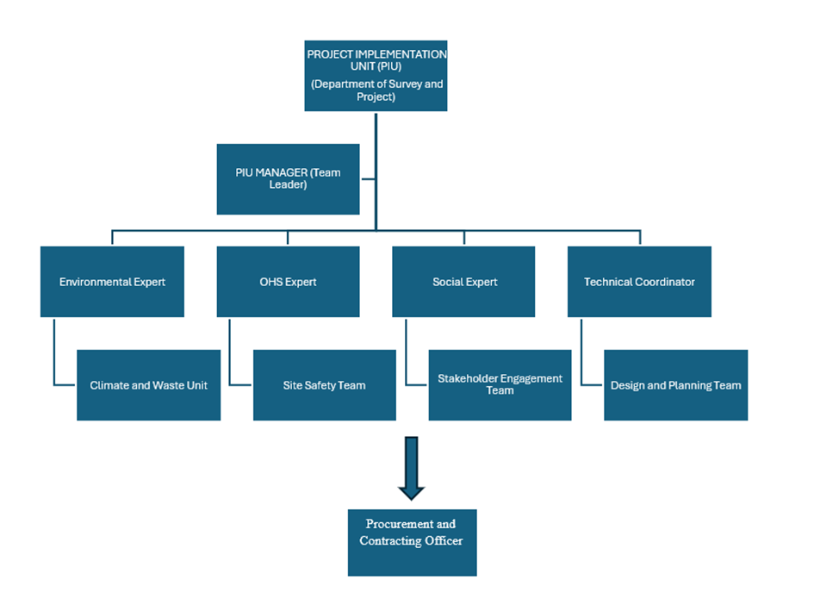
Figure 6.Organisational structure of PIU

5.2. Resources
Kovancılar Municipality is ultimately responsible for the environmental and social performance of the entire sub-project, including the performance of its own contractors and other contractors.A Project Implementation Unit (PIU) will be established to carry out operational and administrative tasks. The PIU staff will be Kovancılar Municipality’s own staff.
The PIU will be primarily responsible for coordinating stakeholder engagement activities with the Contractors as outlined in this SEP. The collection of complaints, questions and feedback will be the direct responsibility of the PIU’s GM contact (GMCP) and the Contractors’ E&S Specialist.
The resources to be provided by Kovancılar Municipality are as follows:
A subproject-specific area on the Kovancılar Municipality’s official website,
An electronic database for grievances,
Stakeholder engagement records,
Printed documents (guides, brochures, posters, etc.) to be used in accordance with the SEP requirements.

5.3. Management functions and responsibilities
Kovancılar Municipality/PIU will be the main party responsible for the implementation of the SEP and coordination with contractors, implementation, monitoring and reporting. Social expert of PIU will be responsible for the inclusion of stakeholder engagement activities in the project management system and the management and implementation of the Stakeholder Engagement Plan.
Kovancılar Municipality/PIU will be responsible for the execution of the stakeholder engagement activity. Detailed roles and responsibilities for stakeholder participation in the subproject are provided in table (See Table 5).
Table 5.Responsibilities
Responsible Party | Roles and Responsibilities
İLBANK(PMU) | - Monitor and control whether Kovancıla Municipalities fulfils its responsibilities;  - Accelerating and monitoring the formation of PIUs to ensure proper implementation of the processes related to the grievance mechanism and stakeholder engagement issues;  - Coordinating the parties for proper implementation of the processes regarding the grievance mechanism and stakeholder engagement issues.  - engagement processes are properly implemented.
Kovancılar Municipality(PIU) | - Implementation of this SEP,  - Planning and implementing SEP activities in close cooperation with ILBANK PMU,  - Reporting Kovancılar Municipality’s SEP-related activities to ILBANK  - Accessing PAPs/stakeholders for site-specific sub-project issues,  - Regional and provincial level outreach,  - Reporting to ILBANK PMU on the implementation of SEP activities,  - Proper implementation of the grievance mechanism defined in the SEP, and  - Informing ILBANK PMU on the general status of implementation.
Kovancılar Municipality | - Act as a focal point for the GM in the PIU  - Keep records and monitor sub-project-related grievances  - Manage and coordinate the resolution process of sub-project related grievances  - Review grievance records for relevant non-compliance issues or recurring issues related to stakeholder engagement and other sub-project activities  - Coordinate and monitor PIU contacts at the contractor level  - Collect sub-project related complaints from all different PIU levels  - Inform PIU and management about the resolution process  - Prepare compiled PIU reports on the sub-project  - Monitor contractors’ complaint records and complaint resolution process and report to PIU in monthly progress reports  - Maintain communication with PIU to respond/resolve grievances
E&S Consultant | - Providing the necessary information to the Sub-project Owner Kovancılar Municipality,  - Conducting an information and public participation (ESMP introduction) meeting for the public and NGOs,  - Finalizing this SEP in line with the concerns/views of the Sub-project stakeholders  - Organizing and conducting a workshop for the Sub-project Owner Kovancılar Municipality on the ESMP expectations and commitments covering the environmental and social impacts and risks related to the sub-project and the relevant measures implemented to prevent, reduce and mitigate the risks and potential adverse impacts
Supervision Consultant | - Review the SEP document to redefine the stakeholders directly or indirectly affected and/or interested in the sub-Project and to follow up the implementation of the methods, instruments, timing and participation levels identified in the SEP,  - Interviews Kovancılar Municipality PIU and others involved in the stakeholder engagement process to review progress and identify critical issues,  - Consults with affected households and community leaders through key informant interviews to identify their feedback on stakeholder engagement performance of the subproject,  - Interacts with various stakeholders to get their views on SEP implementation,  - Controls whether the necessary trainings are given to the personnel who will work during the construction phase,  - Reviews grievance records to identify significant non-compliances or recurring issues with stakeholder engagement and other project activities and to reveal actions,  - Monitors and reports on progress made in relation to the commitments defined in SEP.
Contractor | - Implements and develops Contractor’s social policy,  - Provides necessary resources for proper remedial actions,  - Follows up of the complaints and informs CLO about the solution process,  - Consults with the project affected communities about grievance mechanism, entitlements, construction works and schedule, community safety, compensation of economic losses as needed in coordination with CLO and Social Expert of PIU,  - Keeps records of complaints and participation activities when necessary and forward them to CLO and Social Expert of PIU,  - Reports grievances to GM Team,  - Submits monthly Environmental and Social Monitoring Reports (ESMRs) to Kovancılar Municipality (CLO related parts).  - The construction contractor should develop monthly ESMRs and submits to Municipality through the Supervision Consultant..

GRIEVANCE MECHANISM
Managing, preventing, minimizing and effectively addressing grievances is an integral part of a robust stakeholder engagement strategy. The most important aspect of the grievance mechanism is that all requests are effectively received and recorded in a timely manner, responded to and resolved within a predetermined timeline and based on the content of the grievance. In addition, this mechanism should allow for the consideration and management of anonymous complaints, including complaints related to sexual exploitation and abuse/sexual harassment (SEA/SH).
Therefore, , Grievance Mechanism (GM) is required to be implemented by Kovancılar Municipality / PIU throughout the life of the subproject including pre-construction, construction and operation phases. Comments/complaints in the GM will be received in Turkish and Kurdish, as there will be no need to use another language as almost everyone in the developed GM speaks Turkish. Complaint channels used for applications will be published in Turkish. GM forms and consultation records will be kept in Turkish, but muhtars will provide interpreters for non-Turkish and Kurdish speakers at consultation meetings and in the grievance mechanism. If other languages are needed, interpreters will be provided.

Grievance Mechanism at National Level
ILBANK established a transparent and comprehensive Grievance Mechanism (GM) in September 2021 to receive, assess and resolve grievances related to each international project it finances and will be in place throughout the life cycle of this subproject. Stakeholders may, if they wish, submit their comments, suggestions and grievances to ILBANK through the following means of communication:
Website: https://www.ilbank.gov.tr/form/bilgiedinmeuluslararasi
E-mail: bilguidb@ibank.gov.tr ve etikuidb@ilbank.gov.tr
Phone Number: +90 312-508 79 79
Address: ILBANK International Relations Department, Emniyet Mahallesi, Hipodrom Caddesi, No:9/21, Yenimahalle/ANKARA
Presidential Communication Center: The Presidential Communication Center (CIMER) provides a centralized complaint system for Turkish citizens, legal entities and foreigners. The Presidential Communication Center (CIMER) will serve as an alternative and well-known channel through which Project stakeholders can directly communicate their complaints and feedback regarding the Project to government officials.
- www.cimer.gov.tr
- Call Centre (hotline): 150
- Phone number: +90 312 525 55 55
- Fax number: +90 0312 473 64 94
- Address for Official Letter/Petition: Republic of Türkiye, Directorate of Communications Kızılırmak Neighborhood. Mevlana Boulevard No:144 Çankaya/ANKARA
Mail addressed to Republic of Türkiye, Directorate of Communications
Individual applications at the community relations desks at governorates, ministries and district governorates.
Foreigners Communication Center (YIMER) will be available to Project stakeholders as an alternative and well-known channel for conveying their Project-related grievances and feedback directly to state authorities.
- www.yimer.gov.tr
- Call Centre (hotline): 157
- Phone number: +90 312 515 11 22
- Fax number: +90 0312 920 06 09
- Address for Official Letter/Petition: Republic of Türkiye, Directorate General of Immigration Management Çamlıca Neighbourhood No: 4 Yenimahalle/ANKARA
Mail addressed to Republic of Türkiye, Directorate General of Immigration Management
Individual application to the General Directorate of Migration Management of the Republic of Türkiye

Subproject Level Grievance Mechanism
In line with İLBANK Environmental and Social Management System and World Bank’s Environmental and Social Standard (ESS) 10 a grievance mechanism will be established by Kovancılar Municipality to receive, resolve and follow up the concerns and grievances of sub-project affected communities. Kovancılar Municipality PIU will be accessible to stakeholders and will respond to all grievances (complaints, requests, opinions, suggestions) at the earliest possible time. The most important point in the grievance mechanism is to ensure that all grievances are effectively received, recorded, resolved and responded by the PIU in a predetermined timeline and according to their content, and to ensure that the corrective/regulatory action to be taken is acceptable to both parties. Such responses to grievances will be satisfactory to both parties and activities will be monitored and complainants will be informed about the results of corrective actions. In addition, the mechanism required to designed to be suitable for receiving and redressing anonymous grievances. In addition, the sub-project Grievance Mechanism will include a channel to receive and address confidential grievances related to Sexual Exploitation, Abuse and Sexual Harassment (SEA/SH) for which special measures are taken. Kovancılar Municipality PIU is responsible for establishing close relations with all stakeholders
All grievances received through direct phone calls, e-mails, face-to-face meetings/communications and the Website are recorded and after the recording process, will contact the complainant to explain the sub-project response process and the resolution of the grievance within ten (10) business days. The development of the solution may require consultation with the relevant person(s). The requester will be informed about the methodology followed. Each request must be evaluated with the utmost care, diligence, fairness and impartiality. The proposed solutions are communicated to the complainant with a second notification. If the proposed solution is accepted by the complainant, Kovancılar Municipality will handle the grievance within 15 business days and take corrective measures to resolve the grievance. Grievance registration forms will be sent to the relevant GM Team member (Social Expert of the PMU Team or E&S Expert of the Contractor) on the same day (if possible, as soon as the grievance is received). A notification should be sent to the complainant by GMCP within two (2) business days of the receipt of the grievance, indicating that the grievance has been received and evaluated. The PIU Team will also have access to the grievance record to be created within the scope of the sub-project and will be continuously updated by GMCP or PMU Social Expert. The Grievance Tracking Table will include the complainant/suggestor information, the date of receipt of the grievance/suggestion, the date and method of feedback to the complainant, the current status of the grievance (open, under review, closed, rejected) and the explanation of this current status (e.g. why it was rejected). It will include the closing/rejection and feedback dates. Complaints from contractors and subcontractors will be forwarded to GMCP by the Contractors’ E&S Specialist and will be recorded by GMCP using the grievance registration forms. On the same day, the data will be entered into the Grievance Registry and Grievance Database and made accessible to the PMU Team. During this period, the relevant parties responsible for managing the grievance will be in constant communication with the complainant and all communication will be recorded in the GM system through the Consultation Forms (see Annex-D). The grievance will be closed after the implementation of the decision is completed. After the grievance is closed or resolved, the complainant will be informed with the third notification and the relevant records (Grievance Closure Form, Grievance Record, etc.) will be kept. Unless an alternative agreement is made with the complainant, grievances will be closed within thirty (30) business days from the date of application. If the grievances are not resolved within thirty (30) business days, the extenuating circumstances will be documented and reported. After the complaint is resolved and the result is communicated to the complainant, the appointed GMCP will obtain the necessary signatures and close the grievance by filling out the Grievance Closure Form (see Annex-B). If the decision is not accepted, it will be reconsidered and a revised decision may be proposed. Ultimately, the PIUs will be responsible for consolidating, monitoring and reporting the requests received, resolved and pending regarding the project. All this data will be compiled by the PIU to be reported at the end of each month.
- info@konancilar.bel.tr
- Call Centre (hotline): 153
- Phone number: +90 424 6113415
- Address for Official Letter/Petition: Çarşı Başı, İlhami Ertem Cd., 23000 Kovancılar/Elazığ
Kovancılar Municipality website includes a communication page, which is the mechanism where complaints/requests regarding Kovancılar Municipality activities are submitted and the resolution process is followed (see Figure 7). In addition, many sections of the homepage of Kovancılar Municipality website include information about social media accounts and telephone numbers (such as the Alo 153 line) to which grievances can be submitted.
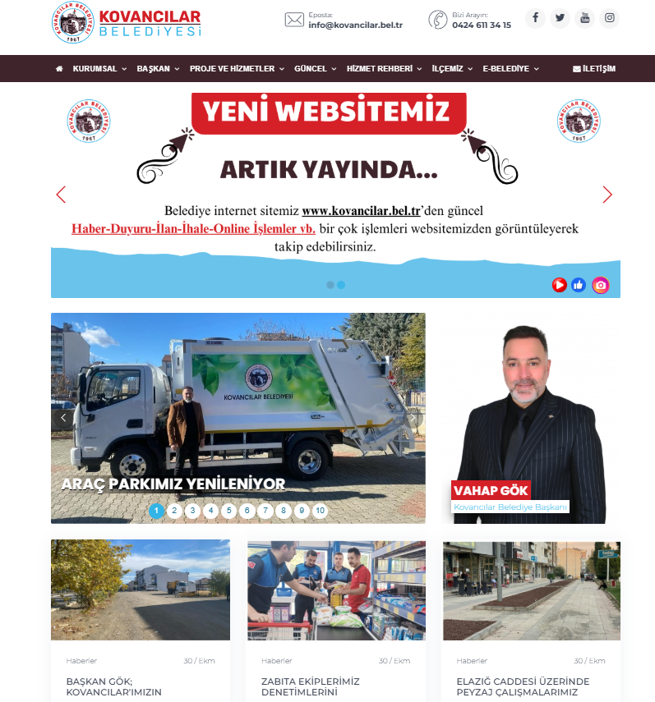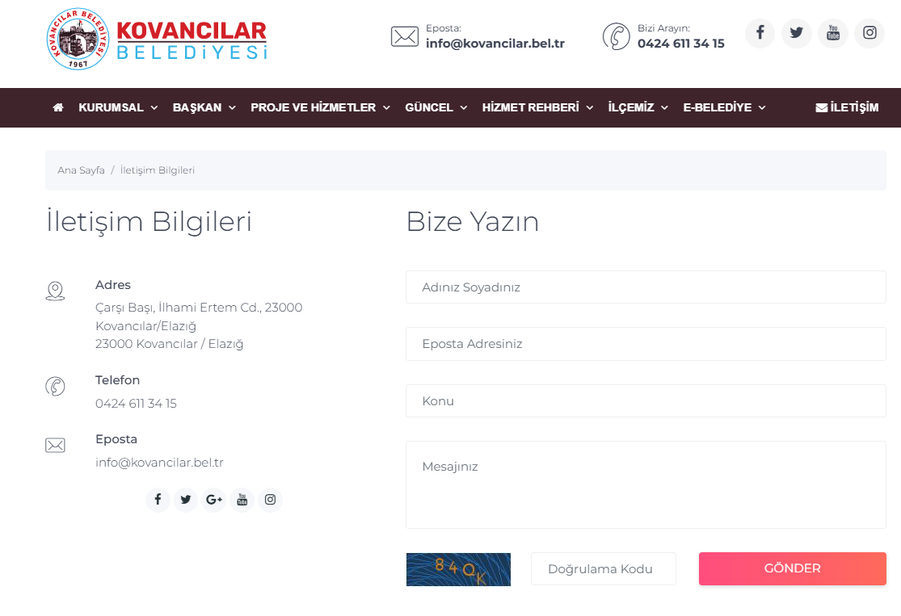
Figure 7. Kovancılar Municipality Website Screenshots

Grievance Mechanism for Workers
The GM for employees (applicable to both Kovancılar Municipality personnel and contractor and subcontractor employees) has been established in accordance with WB ESS2. The implementation of the GM for employees will be ensured throughout the financing life cycle of the sub-project. PIU requests contractors to develop and implement a grievance mechanism for the workforce, including subcontractors, before starting work. Subcontractors will prepare Labor Management Plan that will include a detailed description of the grievance mechanism for employees.
Employees are informed about employee rights, basic occupational health and safety, the grievance mechanism and its operation at the time they start work. An up-to-date list of contact points is available in employee handbooks and/or bulletin boards. All processes related to the grievance mechanism are conveyed in a language that employees can understand. In the event of a dispute regarding employee rights, it is essential that the employee experiencing the problem and his/her manager come together informally and resolve the problem without resorting to the grievance mechanism or legal means.
When employees detect a hazard or risk for which no precautions have been taken regarding occupational health and safety, they inform the employee representative, occupational safety specialist and/or occupational physician selected by the employees about this hazard or risk. The employee representative shall forward the details of the hazard and risk to the occupational health and safety board, if any, or to the employer/employer's representative, and request an evaluation. If the problem is not resolved, all legal rights are reserved by applying to the contractor/subcontractor level SM contact persons through the grievance boxes located at the workplaces. Requests regarding employee rights and occupational health and safety are collected in complaint boxes placed in areas that employees can easily access.
The collected complaints and suggestions are carried out in accordance with the periods determined in the basic process of the grievance mechanism.
After the applications are evaluated, if there is an imminent, urgent and vital danger, a notification can be made directly to the Labor Life Communication Center, ALO 170 line or the Provincial Labor and Employment Institutions Directorates operating in the province. Upon receipt of the requests, the workflow complaint mechanism is carried out in accordance with the workflow chart.
The Kovancılar Municipality/PIU Team will be ready to handle complaints regarding working conditions. The Kovancılar Municipality/PIU Team will evaluate complaints and suggest solutions for direct and contracted employees using this internal GM, which all sub-project employees can easily access.

Sensitive and Confidential Grievances
Specific procedures will be implemented by the subproject in order to address sensitive and confidential grievances, particularly those that are related to Sexual Exploitation and Abuse/Harassment (SEA/SH). These measures will be implemented in accordance with the World Bank ESF Good Practice Note on SEA/SH.
First of all, the complaining party has the right to remain confidential under the Turkish Constitution and the right to apply to the court at any time (in accordance with the Turkish Labor Law No. 4857 and the Turkish Civil Code No. 4721). In addition, Sub-Borrower personnel and sub-project employees will be able to directly communicate (via e-mail) with the Ethics Committee based at İLBANK Head Office in case of sensitive grievances. This issue will be clarified in the consultations carried out and in the introduction of the grievance mechanism. For cases related to gender-based violence, SEA/SH in the workplace or any potential child abuse in sub-project implementation/sub-project sites, the grievance will be directed to the relevant legal authorities or service providers by the Social Focal Point (based at ILBANK Head Office).

MONITORING AND REPORTING

Summary of how SEP implementation will be monitored and reported
It is the responsibility of Kovancılar Municipality to ensure that the SEP is fully integrated and implemented in all sub-project activities. All stakeholders will be consulted and will be able to use the GM throughout the sub-project lifecycle.
The SEP is a dynamic document and will be reviewed, updated and approved by ILBANK when necessary (e.g. changes in the design of sub-project components according to Environmental and Social Monitoring Reports (ESMRs), stakeholders' requests/grievances regarding the sub-project. Implementation of the SEP throughout the implementation of the sub-project, elimination of non-conformities, etc.). Kovancılar Municipality will be responsible for making a statement through communication channels for each updated version of the SEP.
Table 6.Reporting Process Requirements and Distribution of Roles
Responsible Party | Roles & Responsibility
PIU | Submit monthly Environmental and Social Monitoring Reports (ESMR) prepared by the contractor to ILBANK
SupervisionConsultant | Check the monthly Environmental and Social Monitoring Reports prepared by the Contractor and submit them to the PIU
Contractor | The contractor will prepare monthly Environmental and Social Monitoring Reports including grievance records and stakeholder engagement activities to be submitted to Kovancılarl Municipality and submit them to the Supervision Consultant for control.

The ESMRs will include following indicators on grievance mechanism and stakeholder engagement activities:
Indicators for stakeholder engagement:
- Number of public participation meetings
- Number of participants of the public participation meetings disaggregated by gender, age, disability, nationality
- For each meeting, the minutes of meetings, actions agreed during these meetings, the status of these actions and how the comments have been incorporated into the subproject activities will be included in the environmental and social monitoring reports

Indicators for grievance mechanism:
- Number of complaints in total and at local level
- Number of grievances received from stakeholders, sorted and analysed by category
Number of complaints that were (i) opened (ii) open for more than 30 days (iii) resolved (iv) closed and (v) included responses that satisfied complainants during the reporting period.

Reporting back to stakeholder groups
During the preparation and construction phases of the Subproject, the construction contractor will prepare monthly reports on environmental and social performance for submission to Kovancılar Municipality, which will include updates and indicators on the implementation of the stakeholder engagement plan. The monthly reports will be shared with ILBANK and ILBANK will provide quarterly reports to the World Bank.
The person/unit to be assigned by Kovancılar Municipality will provide feedback to stakeholder groups through public meetings, primarily in the subproject impact area. The summary of the public meetings will be published after the removal of identifying information in accordance with the Law on the Protection of Personal Data. Feedback received through the Grievance Mechanism (GM) will be responded to in writing and verbally. Important updates on the sub-project will be published on the website of Kovancılar Municipality.

ANNEXES

Annex-A
Sample Grievance Submission Form

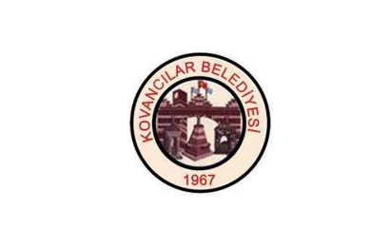 |  | KOVANCILAR MUNICIPALITY  SOLAR POWER PLANT PROJECT
 |  | GRIEVANCE FORM
Person Filling Out the Form: |  |  |  |  | Date and time:
Inteviev Agenda: |  |  |  |  | Reference No: Kovancılar Municipality-Project Code-0001-2..
- INFORMATION ABOUT THE COMPLAINANT
Name surname:  If the complainant requests that this complaint be treated anonymously, this complaint will be recorded anonymously and the request will be met. |  |  |  |  | How received the Grievance:
TC Identification number: |  |  |  |  | Telephone / Toll Free Line
Telephone: |  |  |  |  | Face to Face Meeting
Address: |  |  |  |  | Website / Email
Email: |  |  |  |  | Other (Explain)
Stakeholder Type
Public | PAP |  | Private Enterprise | Trade Association |  | NGO
Interest Groups | Industrial Assosiaction |  | Labor Union | Media |  | University
- DETAILED INFORMATION ABOUT THE GRIEVANCE
Description of the grievance:
Solution method requested by the complainant
Registrant Name Surname/Signature |  | Complainant Name Surname/Signature

Annex-B
Sample Grievance Closure Form

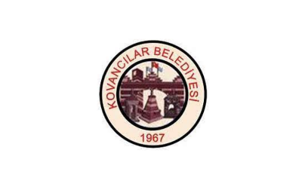 | KOVANCILAR MUNICIPALITY  SOLAR POWER PLANT PROJECT
 | GRIEVANCE CLOSURE FORM
Reference form:
- DETERMİNATİON OF CORRECTIVE ACTION
1
2
3
4
5
- CLOSE OUT THE GRIEVANCE
This section will be filled and signed by the Complainant in case the grievance stated in the “Grievance Registration Form” is resolved
Name Surname /  Signature of the Person  Closing the Complaint/Date | Name Surname /  Signature of Complainant/Date

Annex-C
Grievance Database Form

Complaint Register  Number | How Complaint is Received (Grievance Form, Community Meeting, Telephone) | Level of Grievance (Municipality/Utility Level, Regional ILBANK Office, ILBANK HQ Level) | Date of Complaint  Received | Location of Complaint  Received | Name of Person Receiving Grievance | Land Parcel #  (If complaint is related to land) | Complainant Information |  |  |  |  | Sub-Project Component Related to Complaint | Grievance Category (expropriation/land acquisition related, environmental issues, damages to structures etc.) | Complaint Summary | Grievance Status (open, closed or pending) | Action Taken |  |  |  | Supporting Documents for Grievance Closeout (bank receipt for compensation, grievance closure protocol)
 |  |  |  |  |  |  | Name/Surname | ID Number | Telephone/  e-mail | Village-District | Gender |  |  |  |  | Responsible Person/Department | Action Planned | Due Date of the Addressing the Grievance | Date of Action Taken

Annex-D
Sample Consultation Form (For Stakeholder Participation Meeting(s))
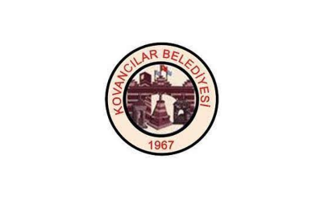 |  | KOVANCILAR MUNICIPALITY  SOLAR POWER PLANT PROJECT
 |  | CONSULTATION FORM
Person Filling Out the Form: |  |  |  | Date timeand place:
Meeting Agenda: |  |  |  | Interview Registration Number: Kovancılar Municipality/Project Code-0001-2..
- INTERVIEW INFORMATION
Interviewed Institution: |  |  |  | Form of Communication
Name and Surname of the Interviewee: |  |  |  | Telephone / Toll Free Line
Telephone: |  |  |  | Face to Face Meeting
Address: |  |  |  | Website / Email
Email: |  |  |  | Other (Explain)
Stakeholder Type
State agency | PEB | Private Enterprise | Job Room |  | NGO
Interest Groups | Industrial Unions | Labor Union | Media |  | University
- INTERVIEW DETAILS (List of Invitees and actual participants, Summary of presentations made by whom, minutes of meeting will be annexes of this form.)
Questions about the project:
Concerns/feedback regarding the project:
Responses to the views expressed above:

Annex-E
Sample Key Informant Interview Form (For Single Stakeholder Interviews)

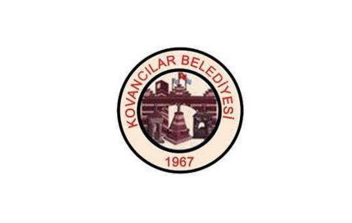 |  | KOVANCILAR MUNICIPALITY  SOLAR POWER PLANT PROJECT
 |  | KEY INFORMANT INTERVIEW FORM
Person Filling Out the Form: |  |  |  | Date timeand place:
Meeting Agenda: |  |  |  | Interview Registration Number: Kovancılar Municipality/Project Code-0001-2..
- INTERVIEW INFORMATION
Interviewed Institution: |  |  |  | Form of Communication
Name and Surname of the Interviewee: |  |  |  | Telephone / Toll Free Line
Telephone: |  |  |  | Face to Face Meeting
Address: |  |  |  | Website / Email
Email: |  |  |  | Other (Explain)
Stakeholder Type
State agency | PEB | Private Enterprise | Job Room |  | NGO
Interest Groups | Industrial Unions | Labor Union | Media |  | University
- INTERVIEW DETAILS (List of Invitees and actual participants, Summary of presentations made by whom, minutes of meeting will be annexes of this form.)
Questions about the project:
Concerns/feedback regarding the project:
Responses to the views expressed above:

Annex-F
Images of consultation meetings
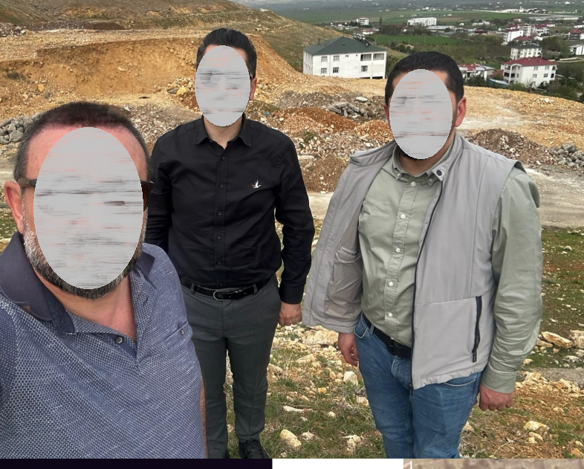
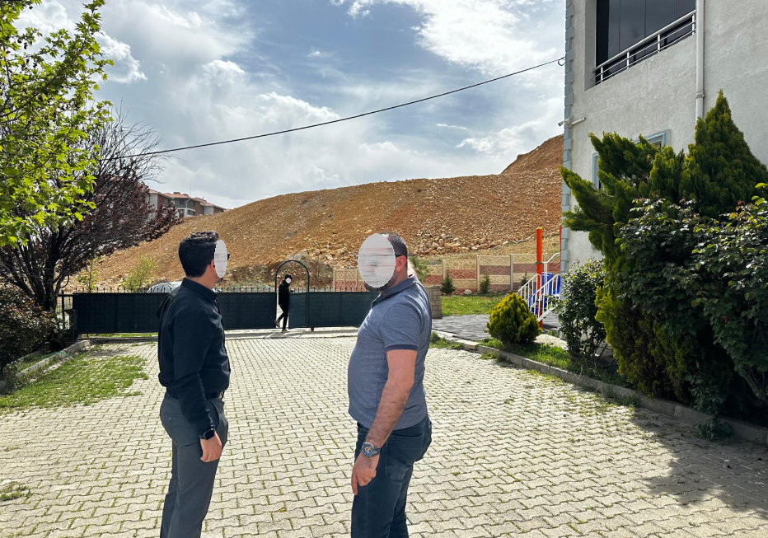

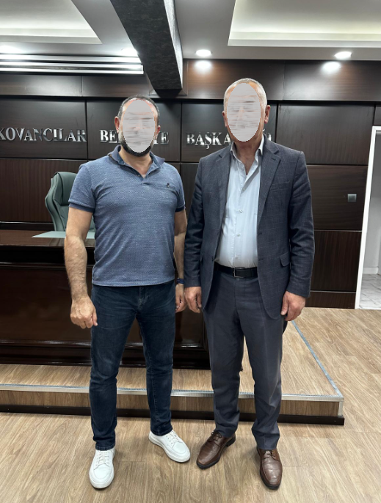
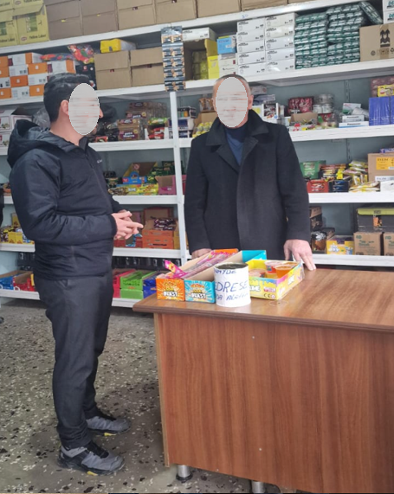.

Annex-G
STAKEHOLDER CONSULTATION MEETING
TURKIYE PUBLIC AND MUNICIPAL RENEWABLE ENERGY PROJECT
(PUMREP)

KOVANCILAR MUNICIPALITY
436 kWp/360 kWe
SOLAR POWER PLANT PROJECT
MINUTES OF STAKEHOLDER CONSULTATION MEETING

Delivery Date  Meeting Date  Meeting Location | :  :  : | August 22, 2025  August 19, 2025  Kovancılar Municipality Conference Hall

- STAKEHOLDER CONSULTATION MEETING
The Kovancılar Municipality 436 kWp/360 kWe Solar Power Plant Project (hereinafter referred to as the "subproject"). The Kovancılar Solar Power Plant Project, planned to be implemented within the scope of the KABYEP (Capital Project Development Plan), is located on lot 3766 block 0, in the İsmetpaşa neighborhood of Kovancılar district, Elazığ province. It aims to support the Kovancılar Municipality in meeting its carbon emission reduction commitments, improving energy security, and expanding the use of renewable energy. The subproject will be financed through the following relevant subcomponents.
An Environmental and Social Management Plan (ESMP) Checklist and a Stakeholder Engagement Plan (SEP) were prepared as part of the project. In addition to these efforts, a Stakeholder Consultation Meeting was held on August 19, 2025, at 2:00 PM, following the completion of the ESMP Checklist. Meeting announcements were published on the Kovancılar Municipality's official website and in national and local newspapers, and the public was informed through brochures posted on neighborhood headmen's offices and bulletin boards.

1.1 Summary
As part of the Public Participation Meeting, representatives from the Kovancılar Municipality and the company that prepared the documents provided information about the sub-project.
Kovancılar Municipality announced the meeting to the İsmetpaşa neighborhood within the project's impact area, including citizens, relevant civil society organizations, and local media representatives.
The Public Participation Meeting was held with the participation of 20 people, including the İsmetpaşa neighborhood headman, İsmetpaşa residents, citizens, and Kovancılar Municipality staff, and lasted one hour in total.
The meeting began with an opening speech by the Mayor of Kovancılar. Information was provided about the subproject process. Following this, the PVGLOBAL Energy project manager gave a presentation detailing the subproject's Environmental and Social Management Plan (ESMP) Checklist and Stakeholder Engagement Plan (SEP). The ESMP outlined the subproject's topic, stakeholders, environmental and social risks, and mitigation measures.
It was also stated that the grievance mechanism would be prioritized and effectively implemented throughout the construction and operation phases of the subproject.
Then, a question-and-answer session was held. The questions were answered by the PVGLOBAL Energy project manager.

1.2 Question & Answer Session
Question 1: Is there a fire risk at the solar power plant? What are the precautions? (İsmetpaşa Neighborhood Mukhtar)
Answer 1: All fire precautions will be taken in accordance with legislation and standards. Employees will be trained on the Fire Emergency Response Plan. A sufficient number of fire extinguishers will be available at various points throughout the plant. (Project Manager)
Question 2: Will the solar power plant project cause environmental pollution? (Citizen)
Answer 2: All precautions will be taken to prevent environmental pollution caused by workers at solar power plants, especially during the construction phase. Actions will be taken in accordance with management plans, procedures, and applicable legislation, and mitigation measures will be implemented. No negative impacts are expected. (Project Manager)

Question 3: Does the solar power plant have a negative impact on human health? (Kovancılar Municipality employee)
Answer 3: There is no scientific data indicating that the solar power plant is harmful to human health. However, broken or waste panels will be stored in closed, leak-proof containers in a temporary storage area on the construction site. The waste panels will then be transferred to licensed recycling facilities. Furthermore, because the subproject is located far from the residential area, no negative impacts are expected. (Project Manager)
Question 4: Does the solar power plant have any negative impact on nearby residential areas? (İsmetpaşa Neighborhood Resident)
Answer 4: No negative impacts are expected from the solar power plant on residential areas. Mitigation measures will be implemented to minimize impacts. To this end, management plans and procedures will be developed and implemented to address environmental and social impacts. There will be a grievance mechanism for the public to convey their complaints. (Project Manager)

1.3 Conclusion
At the approximately one-hour public participation meeting, officials from PVGLOBAL Energy and Kovancılar Municipality provided information about the project, and a question-and-answer session was held. The public was provided with necessary information and answered questions about the 436 kWp/360 kWe solar power plant project, planned for construction on lot 3766 block 0, in the İsmetpaşa neighborhood of the Kovancılar district of Elazığ province.

- Participant List
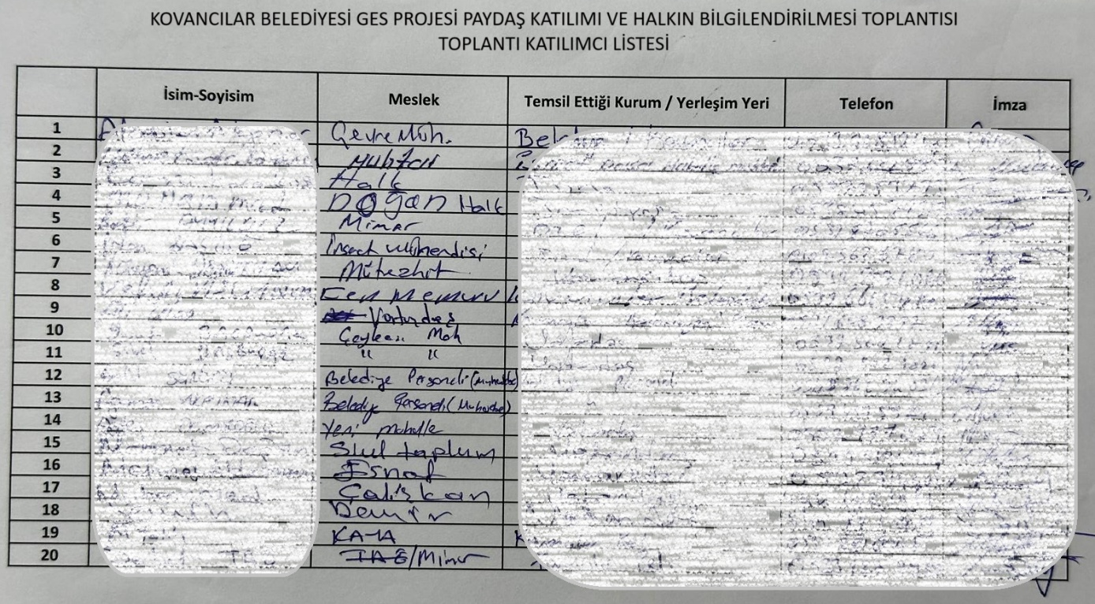

- APPENDICES

Annex 1: Stakeholder Consultation Meeting Photos

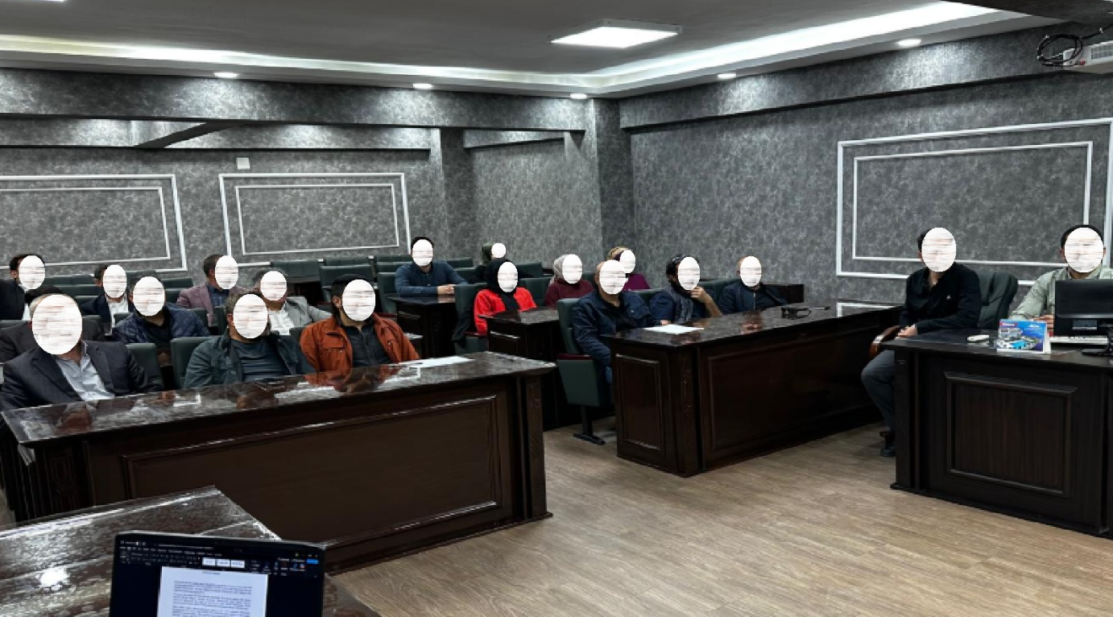
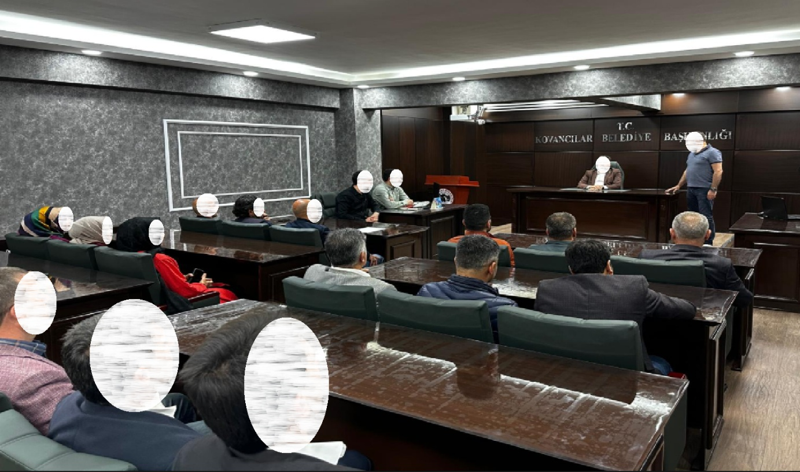

Annex 2 Newspaper Advertisements

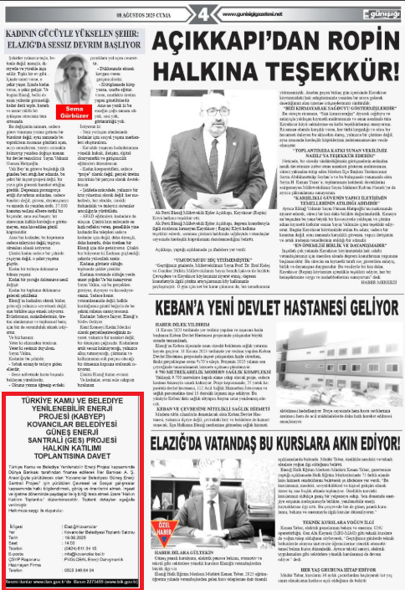
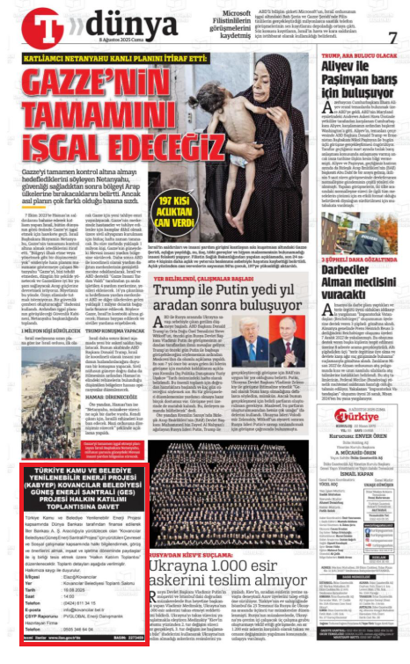

Annex 3 Brochure Distribution at the for Invitation to Stakeholder Consultation Meeting

Annex 4 Stakeholder Consultation Meeting Brochure for the Sub-Project
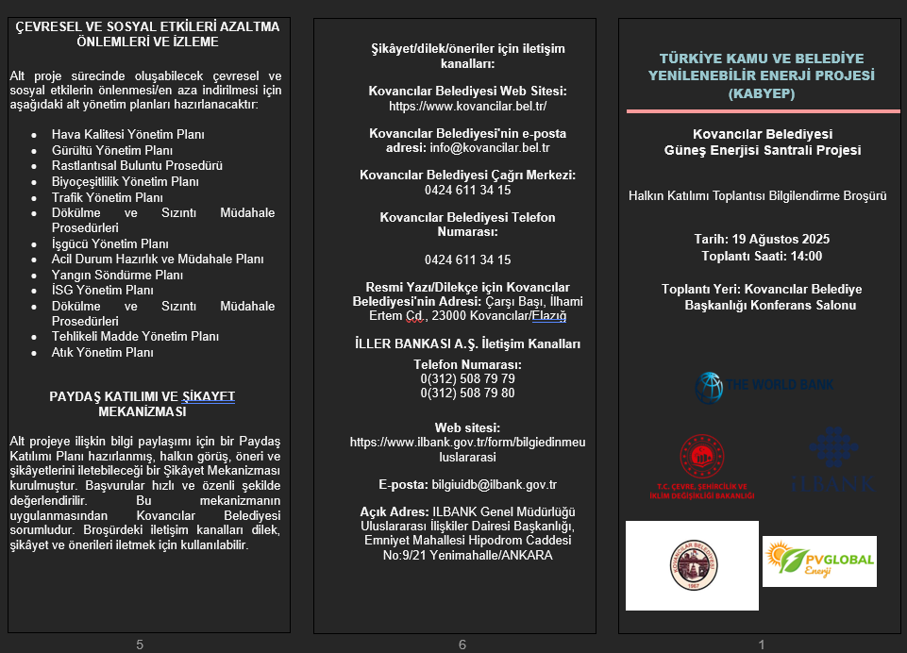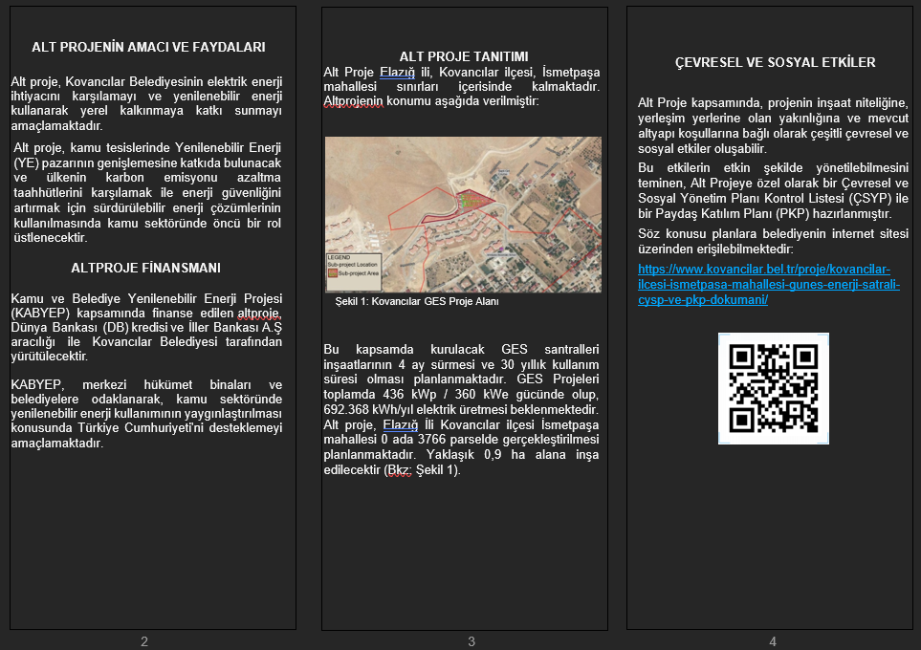

Annex 5 Screenshot of Publishing of ESMP Checklist and SEP on Elazığ Municipality Web Page
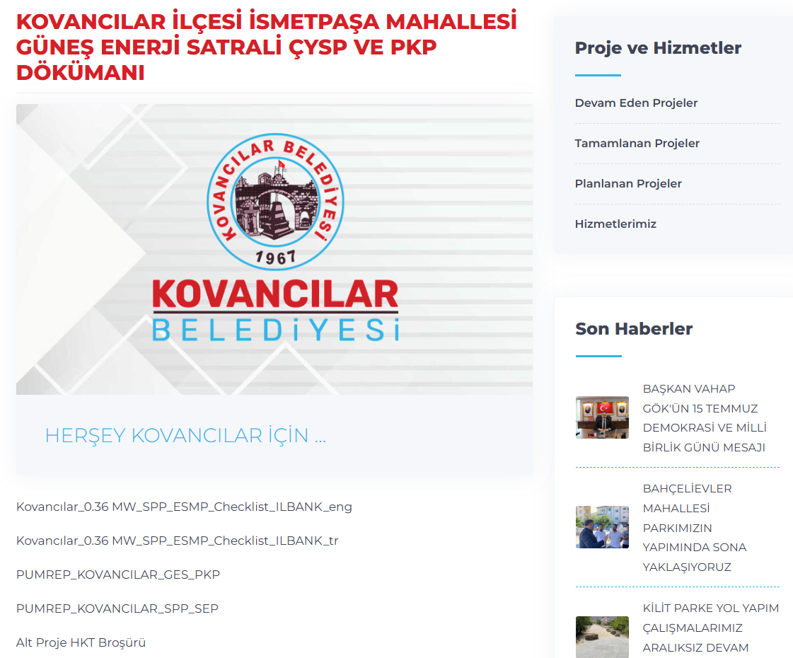

In compliance with the Personal Data Protection Law, the meeting participant list is not published and is stored in the Project Implementation Unit's archives solely for sub-project management purposes. It will be retained for the duration of the sub-project and will not be shared with third parties.

