Environmental and Social Management Plan (ESMP) Checklist

for Kovancılar Municipality
436 kWp/360kWe Solar Power Plant of
Kovancılar Municipality

Date of Issue: July 2025

Document History

Revision | Submitted to | Issue Date | Revision Details
v1 |  | January 13 2025 | Draft
V2 |  | February 18 2025 | Draft
V3 |  | July 18 2025 | Draft

This document has been prepared by PVGLOBAL Energy Company.

Environmental and Social Management Plan (ESMP) Checklist

Part 1: General Subproject and Site Information
1.a) General
Associated ILBANK Project | Türkiye Public and Municipal Renewable Energy Project (PUMREP)
International Financial Institution (IFI) Financing the Project | The World Bank
Project’s E&S Risk Classification according to WB ESF (2018) | Moderate
Subproject Title | Kovancılar Municipality 436 kWp/360kWe Solar (Photovoltaic) Power Plant (SPP)
Sub-borrower Name | Kovancılar Municipality
Responsible ILBANK Regional Directorate (RD) | Elazığ Regional Directorate
Subproject’s E&S Risk Classification according to ILBANK ESMS (2023) | Moderate
Subproject Location | Province: Elazığ  District: Kovancılar  Neighborhood/ Village: İsmetpaşa  Parcel/Block no: . Lot 3766 of block 0
Scope of Subproject and Activity  (in case of any changes of the subproject please fill Appendix-12 and submit to ILBANK) | Technology Monocrystalline Photovoltaic System  Installed power: 436 kWp/360 kWe  Connection power: 360 kWe  Annual electricity generation: 692.4 MWh/ year  Construction Duration: 4 months  Operation Duration (Economic life of the Plant): 25 years  Number of Construction Workers (at peak, including contractors and subcontractors): 8  Number of Operations Workers (at peak): 3  Planned accommodation: Off-site (rented houses in nearby settlements, etc.)
Energy Transmission Line (ETL) | Grid connection: TOKİ transformer station will be connected.  Status of transformer station:Existing  Energy transmission line (ETL): 160 m underground cable  The ETL connection will be connected to the existing TOKİ transformer center by carrying it along the Kanalyurt Street route with a 160 mt underground cable.
Access Roads | The sub-project area is 500 meters away from the Tunceli highway and access to the site will be provided by this road. Access to the sub-project area will be provided by Kanalyurt Street after leaving the Tunceli highway and no new road will be built. Kanalyurt Street, which is asphalt and approximately 10 meters wide, goes all the way to the sub-project area. During access to the site, roads in densely populated residential areas will not be used.
Other Associated Facilities:  Are there any other associated facilities that are not funded as part of the Subproject and are (a) directly and significantly related to the Subproject, (b) carried out, or planned to be carried out, contemporaneously with the Subproject, and (c) necessary for the Subproject to be viable and would not have been constructed, expanded or conducted if the Subproject did not exist? | No
Existing Permits | -EIA Out of Scope’ letter of Provincial Directorate of Environment, Urbanisation and Climate Change dated 28.11.2024 and numbered 11068693  -FIRAT Electricity Distribution Company's Call Permission Letter dated 07.10.2020 and numbered 123367  -Zoning Permit Certificate of Kovancılar Municipality Directorate of Public Works dated 31.12.2020 and numbered 1816  -Kovancilar Municipality Technical Affairs Directorate's SPP Zoning Permit Letter No. 204 dated 18.02.2025  (See Annex-2. )
1.b) Site Description
Subproject Area | The parcel has an area of 9.154,00 m² and 9.154,00 m² will be used for the subproject area.  Number of parcels to be used: 1(Lot 3766 of block 0)  Total title deed area of the parcel: 9.154,00 m²  Total area to be used by the Subproject (within the fence area): 9.154,00 m²
(See Annex-1) : Site Map
(See Annex-4) : Photolog
Who owns the land? Since when? | Kovancılar Municipality Since 03.08.1989  (See Annex-3) : Title Deeds
Land Registry Type according to Title Deed  (agricultural, pasture, vacant, etc.) | Land Plot
Current Land Use  (are there any formal or informal agricultural users, herders, etc.) | No
Other Nearby Facilities and Activities  Are there other industrial or commercial activities operated/operating or planned by the Sub-borrower itself or other public or private third-parties in the vicinity of the Subproject or its components/associated facilities? | No. There is construction excavation material in the sub-project area. This construction excavation material will be removed and the land will be leveled by Kovancılar Municipality before the tender.
Area of Influence | No negative environmental or social impacts are expected within the impact area of the sub-project. The closest household 50 m on the south that may be affected by the project is the İsmetpaşa Neighborhood household. Additionally, the Septi Girls Education Course Building is located 70 meters east of the sub-project area.  The potential impacts of the Project during the construction phase are considered to be short-term and reversible with the implementation of mitigation measures. Temporary deterioration in risks related to air quality, noise, labour, public health and safety, waste management can be expected during the construction phase. Domestic waste, packaging waste of panels and other system equipment (wood, cardboard, plastic, etc.), hazardous waste (chemicals such as paints and solvents and their containers, oily packaging and fabrics, etc.), special waste (waste oils, accumulators and batteries, filters, etc.), excavation and construction waste (scrap, wood, concrete waste, etc.), waste system equipment (panels, cables, electronic devices, etc.) may occur. Impacts will be mitigated or completely eliminated through mitigation measures and management plans. There are no known cultural assets in the sub-project area and the surrounding area of ​​the site. Seyh Mir Mausoleum is located 8 km northwest. However, a Chance Find Procedure has been developed and is outlined in annex (See Annex-9). This procedure will be implemented in the event of any unexpected discoveries during the construction phase. The sub-project area is 500 meters away from the Tunceli-Elazığ highway and the site will be accessed via this road. Kanalyurt Street or Kosova Street will be used to access the land from the Tunceli connection road. No additional road will be opened for the sub-project.
Description of geographic and physical characteristics as appropriate. | Kovancılar is built on a flat and wide plain. It is surrounded by the western extensions of the Southeastern Taurus Mountains. Since the natural vegetation cover has been largely destroyed around the settlements and agricultural areas, it has a steppe appearance. The sub-project land is a slightly rocky, barren land. There is no forest or green vegetation around it.  The sub-project site has an annual sunshine duration of 2664 hours and irradiation values of 1.588 KWh/m2. It has the most ideal energy efficiency due to the mild, less humid climate and high sunshine hours.
Description of biological characteristics as appropriate. | There are grasslands with steppe characteristics in Kovancılar. In these areas, short grasses and some thorny plants generally grow.  There is no nationally protected and internationally recognized areas with high biodiversity value in and around the sub-project impact area. In addition, there are no World Heritage Natural Protected Areas, Biosphere Reserves, Ramsar Wetlands of International Importance, Important Biodiversity Areas, Important Bird Areas.  Although there is no scientific flora identification study in the region, it is generally accepted that the region is home to Iranian-Turanian biodiversity.
Description of geological and hydrographic characteristics as appropriate. | The most important water source of the region is Keban dam lake. It is located 45 km northwest of Elazığ Province and 65 km northeast of Malatya Province and the dam water surrounds Kovancılar. The main river of the lake is the Euphrates. It passes through Kovancılar border. It is a rich region in terms of groundwater reserves. Kapıaçmaz stream passes through Kovancılar.  These rivers and dam lakes are far away from the SPP site. The closest water source to the SPP project area is Kovancılar Pond. It is 2,4 km away. There are no flowing or dry stream beds in the sub-project site and its immediate vicinity. In addition, no groundwater was encountered. Kovancilar District is located within the boundaries of the 3rd Region ground acceleration (PGA) 0.620 g according to the Turkey Earthquake Hazard Map. Quaternary alluviums are observed in low-elevation areas in the district. The sub-project area is located within the East Anatolian Fault (EAF) System and has been continuously tectonically active since the beginning of the Mesozoic Additionally, it is located in the least risky area in terms of landslide risk.
Description of socio-economic characteristics as appropriate. | Socio-economic structure is generally based on agriculture. The majority of the district population is engaged in agriculture and partly in animal husbandry. Since Kovancılar is located on the transit highway, trade has developed in the region. 5% of the population receives social assistance from the state. In recent years, employment in industrial facilities has increased. 10% of the people work in the Eti Krom factory, which is located within the borders of the district and is an important organisation. It is a company located in Kovancılar district and is the world's largest producer of marketable hard chrome ore.  Socio-economically, the sub-project area is located on the edge of settlements. Construction activities are in line with the region's focus on sustainable development and energy efficiency, supporting local initiatives for renewable energy and reducing dependence on non-renewable resources.
If relevant, provide information about the affected settlements. | Nearest settlement(s):  - İsmetpaşa Neighborhood (2024 population is 2018 people according to TÜİK)  Nearest structure(s) to the Sub-Project site:  - The sub-project area is located 50 m away from İsmetpaşa neighborhood.  - There are TOKİ residences belonging to İsmetpaşa neighborhood 50 m south of the Sub-Project site.  - In addition, Septi Girls Education Course Building is located 70 meters east of the sub-project area.
Locations and distance to nearest sensitive receptors such as health care units, schools? | The nearest sensitive receptor is Septi Girls Education Course Building, 70 meters east of the sub-project area. The sub-project area is 220 meters from İsmetpaşa Primary School and 270 meters from the family medicine health center..The sub-project area is 500 meters away from the Tunceli-Elazığ highway and the site will be accessed via this road. Kanalyurt Street will be used as an alternative to Kosova Street for access to the site from the Tunceli connection road (See Annex-1). Access roads to the site are far from residential areas where sensitive receptors are located. The access road passes 50 meters in front of the Septi Girls Education Course Building. No additional road will be opened for the sub-project.
Infrastructure services to be used during the life cycle of the subproject (sewage, electricity, water network, etc.) | In İsmetpaşa neighbourhood, due to its location, there are electricity, sewerage system, water infrastructure networks. There is no need to construct/renew infrastructure services due to sub-project activities.
1.c) E&S Requirements applicable to the Subproject
The subproject will be implemented in line with requirements of applicable national legislation and international agreements and conventions to which Türkiye is a party of.

The following international standards will also be followed as applicable:
- WB Environmental and Social Framework (ESF, 2018) and the Environmental and Social Standards (ESSs) forming part of the ESF
- Good International Industry Practices (GIIPs) including but not limited to WB Group (WBG) General and Industry Sector Environmental, Health and Safety Guidelines (EHSGs)
- International Finance Corporation (IFC) ESMS Implementation Handbook
- ILBANK Environmental and Social Management System (ESMS)

In cases where the requirements of the ILBANK ESMS or national legislation differ from those of the WB ESSs or the levels and measures presented outline in the relevant WBG EHS guidelines, the more stringent standard will apply.

Part 2: Implementation Arrangements
2.b) Implementation Responsibility and Resources
The sub-borrower shall implement and cause the contractor to be adopt and implement this ESMP Checklist satisfactory to ILBANK throughout the sub-financing agreement life cycle.

The sub-borrower is responsible for ensuring that adequate financial and human resources are allocated for the effective implementation of this ESMP Checklist.

Roles and Responsibilities are provided in annex (See Annex-10).
2.c) Organizational Capacity
Sub-borrower:
The sub-borrower shall establish an organizational structure (Project Implementation Unit – PIU) with qualified staff and resources to the satisfaction of ILBANK and maintain it by ensuring that there is qualified staff assigned and serving on the duty throughout the sub-financing agreement life cycle.

The sub-borrower assigns the following personnel to support management and monitoring of subproject E&S risks and impacts and ensure full compliance with the requirements of this ESMP Checklist:
- Environmental Focal Point: Alpaslan AKPINAR Environmental Engineer 11 Year
- Social Focal Point ((who will also act as the Grievance Mechanism (GM) Focal Point): Ayşe TEK KAYA Mechanical Engineer 4 Year
- Occupational Health and Safety (OHS) Specialist: Esma GENÇYİĞİT 4 Year
Contractors:
The sub-borrower shall obligate awarded contractors to establish and maintain throughout the contract duration an organizational structure with qualified staff and resources.

This shall be achieved through assigning the following personnel under the contractor’s organization prior to commencement of works:
- One (1) Environmental Specialist: Please insert name-surname, position/title, length of professional experience
- One (1) Social Specialist: Please insert name-surname, position/title, length of professional experience
- One (1) Occupational Health and Safety (OHS) Specialist: Please insert name-surname, position/title, length of professional experience, expertise class

The sub-borrower shall in writing notify ILBANK of the assigned contractor personnel prior to commencement of works.
2.d) Grievance Mechanism (GM)
The sub-project's Grievance Mechanism (GM) shall be implemented in alignment with İLBANK’s GM framework, available at the official İLBANK website The GM aims to provide an accessible and transparent process for stakeholders to raise concerns, provide feedback, and resolve grievances related to the sub- project.

The sub-borrower shall require the contractors to prepare notification board/sign and post them at or around the worksite prior to commencement of works. The board/sign will include contact details for public to raise their subproject-related grievances and feedback (please see Annex-5. for the template).

The grievances shall be recorded by the sub-borrower, construction supervision consultant and the contractor, and submitted to ILBANK weekly (see Annex-6. for Forms & Annex-7. for Register).

Sensitive complaints will be reported to WB within 48 hours following the grievance received by ILBANK.
2.e) Monitoring and Reporting
The sub-borrower shall promptly notify ILBANK of any incident or accident related to the subproject which has, or is likely to have, a significant adverse effect on the environment, the affected communities, the public or workers, including, inter alia, cases of sexual exploitation and abuse (SEA), sexual harassment (SH), and accidents that result in death, serious or multiple injury.

This notification shall be done by using ILBANK’s E&S Incident Notification Form template (see Annex-8). Completed E&S Incident Notification Form shall be submitted to ILBANK by the sub-borrower within 48 hours of the incident or accident (contractor shall notify the sub-borrower within 24 hours of the incident or accident).

The periodic E&S monitoring reporting requirements for the subproject is as follows:

- Construction contractor will prepare monthly E&S monitoring reports (ESMRs) and submit to supervision consultant (“müşavir”).
- During the construction phase, the sub-borrower, with support from supervision consultant, will prepare quarterly ESMRs and submit to ILBANK.
- During the operation phase (throughout sub-financing agreement lifecycle, until the completion of repayment period), the sub-borrower will prepare annual ESMRs and submit to ILBANK.

ILBANK will provide the sub-borrower with the required template for the periodic ESMRs.

The Roles and Responsibilities are provided in annex (See Annex-10).

Part 3: ESMP Matrix: Risk and Impacts, Mitigation and Monitoring
As the Sub-project involves both construction and operational activities, the ESMP consist of two components applicable to respective Sub-project phase, as follows:
• Construction ESMP Matrix
• Operation ESMP Matrix

3.a) Construction ESMP Matrix
No. | Risks and Impacts | Receptor(s) | Proposed Mitigation Measure | Responsible Parties
Labor and Working Conditions
 | Working Conditions | Construction workforce  Employees | - Conduct daily toolbox talks covering the OHS Plan and labor conditions.  - Develop and implement a subproject-specific simplified Labor Management Procedure (SLMP, see Annex-9) to ensure compliance in recruiting and managing all employees.  - Enforce strict prohibition of child labor, forced labor, and unregistered labor as per SLMP requirements.  - Workers will be provided with documented information that is clear and understandable regarding their rights under national labor law, including collective agreements, and their rights related to hours of work, wages, overtime, compensation, and benefits at the start of the working relationship and whenever any material changes occur.Recruitment procedures will comply with national labor legislation and ESS2, and an accessible grievance mechanism for workers will be implemented and maintained.  - For the accommodation of the workers, the contractor will rent a sufficient number of houses in Kovancılar city center under suitable conditions, taking into account the number of workers.  - The workers' access to the project area will be provided by free shuttles provided by the contractor. | Contractor  Supervision Consultant  Kovancılar Municipality
 | General OHS risks | Construction workforce | - Develop a comprehensive risk assessment document for sub-project, addressing specific risks and defining mitigation measures.  - Ensure that all employees, including subcontractors, receive necessary OHS training covering identified risks.  - Prepare sub-project management plans, including Safe Work Procedures and an Emergency Response Plan.  - Enforce safety procedures and provide appropriate PPE to all employees.  - Incorporate job-specific safety procedures and requirements in OHS training programs.  - Prepare machine and operation specific “Safe Working Procedures” for all safety critic equipment and machinery and notify all workforce by signature. | Contractor  Supervision Consultant  Kovancılar Municipality
 | Physical Hazards: Lifting Operations OHS Risks | Construction workforce | - Ensure that lifting area will be enclosed with fence to prevent access to the lifting area during lifting work.  - Ensure that warning signs will be installed for lifting activities  - Ensure that safety procedures will be used for lifting operations.  - Ensure that lifting work will be carried out by well trained, qualified, and certified lifting team and with proper communication means and flag man.  - Ensure that workers will be provided with all necessary PPE and safety materials.  - Ensure all equipment used for lifting operations including slings, chains and hooks are checked technically and records are kept according to local safety legislation. | Contractor  Supervision Consultant  Kovancılar Municipality
 | Physical Hazards: Rotating and Moving Equipment | Construction workforce | - Design machines to eliminate trap hazards and ensure that extremities are kept out of harm’s way under normal operating conditions; i.e. availability of emergency stops dedicated to the machine and placed in strategic locations;  - If a machine or equipment has an exposed moving part or an exposed pinch point that could endanger the safety of any worker, ensure that the machine or equipment is equipped with and protected by a guard or other device that prevents access to the moving part or pinch point. Guards should be designed and installed in conformance with appropriate machine safety standards;  - Ensure that machinery with exposed or protected moving parts or in which energy can be stored (e.g. compressed air, electrical components) is turned-off, disconnected, isolated and de-energized (Locked Out and Tagged Out) during service or maintenance;  - Where possible, ensure that equipment is designed and installed to enable routine servicing, such as lubrication, to be carried out without removing guarding devices or mechanisms. | Contractor  Supervision Consultant  Kovancılar Municipality
 | Physical Hazards: Electrical Hazards | Construction workforce | - No one without a valid certification on vocational training on electricity will be allowed to work on electrical installations.  - Ensure that all energized electrical devices and lines are marked with warning signs;  - Ensure that the devices are locked (de-charging and leaving open with a controlled locking device) and labeled (warning sign placed on the lock) during service or maintenance;  - Ensure that all electrical cords, cables, and hand power tools are checked for frayed or exposed cords. Also, ensure that the manufacturer's recommendations for the maximum permitted operating voltage of portable hand tools are followed;  - Ensure that all electrical equipment used in environments that are or may be wet is double insulated/grounded; use equipment with ground fault interrupter (GFI) protected circuits;  - Ensure that power cords and extension cords are protected against damage from traffic by shielding or suspending above traffic areas;  - Ensure that high-voltage equipment ('electrical hazard') and service rooms where access is controlled or prohibited are properly labeled;  - Ensure that "No Approach" zones are established around or under high voltage lines;  - Ensure that construction vehicles or other vehicles with rubber tires that come into direct contact with or arc across high-voltage cables are taken out of service for 48 hours;  - Ensure that all buried electrical cables are thoroughly identified and marked prior to any excavation work.  - Ensure that special training programs are organized for employees on electrical hazards and safety precautions.  - Ensure that rapid response teams and emergency plans are established for electrical accidents.  - Ensure that regular electrical safety inspections are conducted in the project area.  - Ensure that periodic inspections are conducted to ensure that employees use appropriate personal protective equipment (PPE). | Contractor  Supervision Consultant  Kovancılar Municipality
 | Physical Hazards: Welding and Hot Works | Construction workforce | - Ensure that appropriate eye protection, such as welder's goggles and/or a full-face shield, and respiratory protection is provided for all personnel involved in or assisting with welding operations;  - If welding or hot cutting is performed outside of established welding work stations, ensure that special hot work and fire prevention precautions and Standard Operating Procedures (SOPs) are in place, including "Hot Work Permits, stand-by fire extinguishers, stand-by fire watch and maintaining fire watch for up to one hour after welding or hot cutting is finished";  - Ensure that areas where welding or hot work is performed are cleared of flammable materials (e.g. fuel, solvent, spark-ignitable materials) and should be checked regularly.  - Ensure that all employees are trained and informed about welding operations and the safe management of hot work. | Contractor  Supervision Consultant  Kovancılar Municipality
 | Fire Safety Prevention Measures and Emergency Response | Construction workforce  Flora and fauna  Soil, water resources | - Prepare an Emergency Response and Evacuation Plan before the commencement of works.  - Ensure all employees are trained for their responsibility to report dangers and firefighting measures  - Ensure that all flammable and hazardous materials are stored in designated, secure areas away from ignition sources.  - Ensure firefighting systems and equipment are available  - Ensure fire and emergency drills are conducted regularly.  - Designate trained fire wardens for each area to lead evacuations and coordinate with emergency responders.  - Keep an up-to-date list of emergency contacts, including local fire departments and hospitals, for quick access in case of fire.  - Ensure an appropriate number of trained first-aiders are present within the subproject area. | Contractor  Supervision Consultant  Kovancılar Municipality
 | Physical Hazards: Ergonomics, Repetitive Motion, Manual Handling Lifting | Construction workforce | - Establish clear weight limits for manual handling tasks and label heavy loads accordingly;  - Ensure that mechanical assists are used to eliminate or reduce the effort required to lift materials, hold tools and work objects, and that more than one person is lifting if weights exceed thresholds;  - Ensure that tools are selected and designed that reduce force requirements and holding times and improve postures;  - Ensure that user-adjustable workstations are provided;  - Ensure that rest and stretch breaks are incorporated into work processes and job rotation is in place;  - Ensure quality control and maintenance programs are in place that reduce unnecessary forces and effort;  - Ensure that additional special circumstances, such as left-handed people, are considered. | Contractor  Supervision Consultant  Kovancılar Municipality
 | Physical Hazards: Industrial Vehicle Driving and Site Traffic | Construction workforce | - Ensure that industrial vehicle operators are trained in the safe use of specialized vehicles such as forklifts, including safe loading/unloading, load limits;  - Make sure drivers undergo medical supervision;  - Ensure that moving equipment with restricted rear visibility is equipped with audible back-up alarms;  - Ensure that rights of way, site speed limits, vehicle inspection requirements, operating rules and procedures and control of traffic patterns or direction are established;  - Ensure that deliveries and movement of private vehicles are restricted to defined routes and areas, with 'one-way' movement preferred where appropriate. | Contractor  Supervision Consultant  Kovancılar Municipality
 | Physical Hazards: Chemical Hazards | Construction workforce  Flora and fauna  Soil, water resources | - Ensure that the hazardous substance is replaced with a less hazardous substitute;  - Ensure that engineering and administrative control measures are in place to prevent or minimize the release of hazardous substances into the working environment, keeping the exposure level below internationally established or recognized limits;  - Ensure that the number of workers exposed or likely to be exposed is minimal;  - Ensure that chemical hazards are communicated to workers through labeling and marking according to nationally and internationally recognized requirements and standards, including International Chemical Safety Cards (ICSC), Material Safety Data Sheets (MSDS/SDSs) or equivalent. Any means of written communication should be in an easily understood language and be readily available to exposed workers and first-aid personnel;  - Ensure that employees are trained in the use of available information (such as MSDSs/SDSs), safe working practices and proper use of PPE.  - Ensure workers have access to suitable personal protective equipment (PPE), such as gloves, respirators, goggles, and protective clothing, based on the specific chemical hazards.  - Store hazardous substances in designated areas with appropriate ventilation, labeling, and secure containment to prevent accidental exposure or spills.  - Develop and implement a spill response (as a part of Emergency Response Plan) that includes containment, cleanup, and disposal of hazardous substances, along with emergency contact information.  - Dispose of chemical waste according to regulations to prevent environmental contamination and worker exposure.  - Regularly inspect and maintain chemical handling equipment, storage areas, and PPE to prevent leaks or accidental releases. | Contractor  Supervision Consultant  Kovancılar Municipality
 | Gender-Based Violence (GBV); Sexual Exploitation and Abuse/Sexual Harassment (SEA/SH) on Employees; Gender Inequality | Construction workforce | - Provide GBV and SEA/SH awareness sessions for the management teams of the construction contractor and consultants to promote understanding and accountability.  - Conduct regular awareness meetings with workers to educate them on GBV and SEA/SH issues and the importance of respectful workplace conduct.  - Ensure all workers receive training on recognizing, preventing, and responding to GBV and SEA/SH incidents.  - Require all workers to review, sign, and adhere to a Code of Conduct that explicitly addresses unacceptable behaviors related to GBV and SEA/SH.  - Implement a confidential and accessible grievance mechanism specifically designed to capture and address GBV and SEA/SH-related complaints in a timely manner. | Contractor  Supervision Consultant  Kovancılar Municipality
Resource Efficiency and Pollution Prevention and Management
 | Waste Management - General | Communities  Construction workforce  Flora and fauna  Soil, water resources | - Separate waste at the source into waste categories determined in Waste Management Regulation, establish temporary waste storage area  - Place labeled bins for each type of waste at strategic locations on-site to ensure correct disposal by workers.  - Implement practices to reduce waste generation by optimizing material use and reusing materials where possible.  - Contract with local recycling facilities to ensure that recyclable materials (e.g., metals, paper, plastic) are properly processed.  - Store waste in designated, secured areas to prevent littering, leaching, and environmental contamination.  - Use leak-proof containers for hazardous or liquid waste and ensure they are adequately labeled.  - Contract with licensed waste disposal companies to handle non-recyclable and hazardous wastes in accordance with Waste Management Regulation.  - Track and document the disposal process to ensure compliance and accountability.  - Conduct regular awareness sessions and training for workers on waste reduction techniques, proper disposal practices, and the importance of waste management.  - Regularly monitor waste management practices, conduct site inspections, and assess waste volumes to identify areas for improvement.  - Establish a reporting system to document waste types, quantities, and disposal methods.  - Develop a comprehensive waste management plan that includes waste reduction targets, disposal methods, monitoring schedules, and assigned responsibilities for effective waste management throughout the project.  - Use containment systems for waste that poses spill risks, and keep spill kits accessible. Train staff on immediate spill response actions to prevent soil and water contamination.  - Conduct maintenance tasks, such as oil changes and battery replacements, off-site; | Contractor  Supervision Consultant  Kovancılar Municipality
 | Waste Management -Electronic Waste Disposal | Communities  Construction workforce  Soil and water resources | - Contract with recycling facilities and/or manufacturers to ensure proper disposal or recycling of obsolete equipment;  - Agreements will be set with e-waste recycling facilities to ensure responsible disposal of electronic waste from solar panels, inverters, batteries, etc. | Contractor  Supervision Consultant  Kovancılar Municipality
 | Wastewater Management | Flora and fauna  Soil, water resources | - Construct septic tanks for collecting wastewater from site staff;  - Regularly dispose/vacuum wastewater in the septic tank to prevent overflow, reduce the risk of contamination, and ensure the proper functioning of the system. | Contractor  Supervision Consultant  Kovancılar Municipality
 | Soil and Groundwater Contamination | Communities  Construction workforce  Flora and fauna  Soil and water resources | - Contain and clean up any oil, chemical, lubricant, or fuel spill immediately to prevent environmental contamination.  - Implement spill prevention and response measures. Maintain spill containment and clean-up kits on-site. Ensure all spills are contained, cleaned, and disposed of by licensed waste management companies.  - Conduct routine servicing of construction vehicles and equipment at designated off-site locations to minimize the risk of leaks or spills.  - Perform refuelling in designated areas following strict protocols to prevent accidental spills.  - Collect and store waste oil securely for recycling or dispose of it through licensed waste vendors to ensure safe handling.  - Provide adequate sanitary facilities, including toilets and showers, for the construction workforce. Ensure prompt repairs and maintenance in the event of any leaks or spills to maintain hygiene and safety standards. | Contractor  Supervision Consultant  Kovancılar Municipality
 | Dust and Gaseous Emissions | Communities  Construction workforce  Flora and fauna  Ambient air quality | - Apply water spraying to suppress dust when dusting occurs on roads and construction area. Use water tankers to supply water for this purpose.  - Inform communities/residential areas nearby about the schedule and nature of construction activities as part of the Stakeholder Engagement Plan (SEP).  - Carry out loading and unloading of trucks carefully to prevent materials from dispersing or scattering.  - Cover transport trucks with tarpaulins on public roads when arriving at or leaving the site to minimize dust. Clean truck tires before leaving the site to prevent mud and debris from spreading onto public roads.  - Enforce a speed limit for trucks to reduce dust and improve site safety.  - Use modern equipment and vehicles that meet relevant emission standards. Regularly inspect and maintain exhaust systems to ensure emission levels remain within safe limits.  - Implement good site practices by using low-emission construction equipment and vehicles. Utilize cleaner fuels and technologies to reduce dust and other airborne pollutants.  - Implement a grievance mechanism to address community concerns. Halt work in case of grievances until corrective measures are in place. | Contractor  Supervision Consultant  Kovancılar Municipality
 | Environmental Noise | Communities  Construction workforce | - Prohibit the operation of construction machinery at night to minimize noise disturbances.  - Inform communities/residential areas nearby about the timing and nature of construction activities as part of the Stakeholder Engagement Plan (SEP).  - Ensure that machinery and equipment used during land preparation and construction are distributed evenly throughout the site rather than concentrated in one location.  - Choose construction machinery and equipment with low noise emissions to minimize noise impact on the surrounding area.  - Use noise barriers or enclosures for loud equipment.  - Conduct regular and periodic maintenance of construction machinery and equipment, including daily checks before each shift, to ensure optimal performance and reduce noise levels.  - Ensure all vehicles used for transportation comply with the speed limits to minimize noise and enhance safety.  - Establish a grievance mechanism to receive and address complaints related to noise and other nuisances from the community.  - Halt construction activities in response to grievances until appropriate preventive measures are implemented to address the issues raised. | Contractor  Supervision Consultant  Kovancılar Municipality
 | Hazardous Substances Management | Construction workforce  Communities  Flora and fauna  Soil and water resources | - Maintain a comprehensive record of the types, quantities, and properties of hazardous materials to be stored on-site.  - Establish a designated storage area specifically equipped for the safe storage of hazardous and toxic materials.  - Ensure all storage containers are clearly labelled with appropriate hazard warnings, safety information, and emergency contact details to facilitate proper handling and identification. All chemicals will be managed in accordance with their Material Safety Data Sheets (MSDS).  - Utilize suitable containers, tanks, and bunding systems to contain hazardous materials and prevent spills, leaks, or releases. Implement secondary containment measures, such as berms, dikes, or containment basins, to capture any accidental releases.  - Ensure adequate ventilation and venting systems are in place within storage areas to prevent the accumulation of hazardous vapours or gases.  - Identify and safely remove hazardous materials, including lead-containing components from solar panels and electronic waste from inverters, following proper disposal protocols.  - Implement appropriate containment and handling procedures to minimize the risk of spills or releases of hazardous substances during storage and handling.  - Arrange for the proper disposal or recycling of hazardous materials through licensed facilities to ensure safe and compliant waste management. | Contractor  Supervision Consultant  Kovancılar Municipality
Community Health and Safety
 | Increased traffic | Communities | - Coordinate traffic management to regulate construction vehicle movement.  - Schedule construction activities during off-peak hours to minimize traffic congestion.  - Ensure coordination and develop infrastructure upgrades or expansions in advance of the sub-project, including improvements to roads, utilities, and telecommunications if necessary.  - Use flagmen and signage to direct traffic safely around construction area.  - Provide regular updates to the community about construction schedules and traffic impacts.  - Ensure all construction vehicles comply with speed limits specified in the regulations and are maintained to minimize emissions and noise.  - Limit vehicle speed on unpaved roads to 30 km/h.  - Conduct safety training for construction workers on road safety protocols and provide road safety training for all drivers.  - Use safe traffic control measures, including road warning signs, speed bumps, and flag persons as necessary.  - Monitor traffic conditions and adjust operations as necessary to ensure safety.  - Repair any damage to the roads promptly.  - Establish a grievance mechanism for community members to report traffic concerns.  - Prepare an emergency response plan and protocols to address potential infrastructure failures, accidents, or natural disasters during construction. | Contractor  Supervision Consultant  Kovancılar Municipality
 | Risks related with Gender Based Violence (GBV) Sexual Exploitation Abuse / Sexual Harassment (SEA/SH) | Communities | - Deliver ethical rules and public communication training to all employees to prevent gender-based violence (GBV), harassment, and abuse in the workplace.  - Require all workers to sign and adhere to a code of conduct that promotes respectful behaviour.  - Conduct regular awareness-raising sessions on-site focused on GBV prevention and other relevant social issues.  - Establish a grievance mechanism to receive and address complaints related to GBV and workplace misconduct.  - Women's complaints of sexual abuse will be handled in a confidential manner and women staff (e.g. Women Social Workers) will be employed within the grievance mechanism to ensure that these complaints are shared | Contractor  Supervision Consultant  Kovancılar Municipality
 | Local Economy, Livelihood Sources and Employment | Communities | - Prioritize local hiring for unskilled, semi-skilled, and skilled positions within the scope of the sub-project.  - Regularly engage with local communities and maintain a grievance mechanism to address community concerns and feedback. | Contractor  Supervision Consultant  Kovancılar Municipality
 | Impacts on Vulnerable and Disadvantaged Individuals and Groups | Communities | - Develop a recruitment policy that includes non-discriminatory hiring practices, tailored training programs for vulnerable groups, and support services such as transportation and childcare to facilitate workforce participation. | Contractor  Supervision Consultant  Kovancılar Municipality
Land Acquisition, Restrictions on Land Use and Involuntary Resettlement
 | Impacts on Local Communities using the Site and Its Environs for Grazing, Agriculture or Beekeeping | Communities | - Ensure availability of grievance mechanism for stakeholders affected by land use.  - No work will be carried out outside the project area. In case additional land is needed, necessary permits and approvals will be obtained.  - If accidental damage to adjacent land, structures or crops/assets occurs, the Contractor shall provide appropriate shall compensate and indemnify | Contractor  Supervision Consultant  Kovancılar Municipality
Biodiversity Conservation and Sustainable Management of Living Natural Resources
 | Disturbance on Biodiversity | Flora and fauna | - Engage qualified biodiversity experts to conduct pre-construction surveys to identify presence and distribution of flora and fauna on the subproject site, if any, with a focus on impact on habitats such as nesting or burrowing sites, to avoid disturbance or destruction during construction activities.  - Implement a gradual construction approach to allow fauna species time to escape or provide for their relocation to suitable habitats.  - Schedule construction activities during periods of low wildlife activity, avoiding nesting seasons for birds and hibernation periods for mammals.  - Minimize vegetation removal by conducting thorough surveys to avoid unnecessary clearing.  - Restore natural vegetation upon completion of construction activities to enable species to re-inhabit surrounding areas.  - Install exclusion fencing to prevent animals from entering construction zones, using wildlife-friendly designs that allow small animals to pass through safely.  - Install barriers around known burrows or nesting sites to protect them from disruption during construction, using temporary or permanent solutions as necessary.  - Clearly separate subproject construction sites and access roads from other areas with appropriate signage and fencing, limiting personnel and vehicle access to these areas.  - Reduce habitat degradation by keeping vehicles on designated access roads and minimizing pedestrian traffic in intact areas. | Contractor  Supervision Consultant  Kovancılar Municipality
Cultural Heritage
 | Impacts on Cultural Heritage | Cultural heritage | - Develop and implement the Chance Finds Procedure (see Annex-10) to ensure timely identification and appropriate management of any chance findings during sub-project implementation.  - Include the Chance Finds Procedure as part of toolbox training sessions during construction to raise awareness among workers.  - Stop construction work immediately if any chance finds are encountered.  - Inform the relevant Preservation Board or Museum Directorate immediately, and ensure the security of the area by the contractor. Construction work will not resume until official notification is received. | Contractor  Supervision Consultant  Kovancılar Municipality
Stakeholder Engagement and Information Disclosure
 | Insufficient Stakeholder Engagement Activities and Public Consultation. | Communities  Construction workforce | - Create channels for interaction and communication with local communities, ensuring that engagement activities are scheduled at convenient times.  - Conduct regular consultations with relevant authorities and local communities to discuss project management and gather feedback. | Sub-borrower  Supervision Consultant  Kovancılar Municipality

3.b) Operation ESMP Matrix

Ref. | Impact Description | Sensitive Receptor(s) | Management/ Mitigation Measure | Responsibility for Implementation of Mitigation Measure
Labor and Working Conditions
 | Improper Working Conditions | Employees | - Conduct daily/weekly toolbox talks covering the OHS Plan and labor conditions.  - Apply the SLMP to ensure compliance in recruiting and managing all employees.  - Enforce strict prohibition of child labor, forced labor, and unregistered labor as per SLMP requirements.  - Provide employees with clear, documented information on their labor rights, including working hours, wages, overtime, compensation, and benefits at the start of employment and whenever material changes occur.  - Implement and maintain an accessible Grievance Mechanism for workers. Inform all workers at recruitment. | Sub-borrower
 | General OHS risks | Employees | - Develop a comprehensive risk assessment document for sub-project, addressing specific risks and defining mitigation measures.  - Ensure that all employees, including subcontractors, receive necessary OHS training covering identified risks.  - Prepare sub-project management plans, including Safe Work Procedures and an Emergency Response Plan.  - Enforce safety procedures and provide appropriate PPE to all employees.  - Incorporate job-specific safety procedures and requirements in OHS training programs. | Sub-borrower
 | Physical Hazards: Lifting Operations OHS Risks | Employees | - Ensure that lifting area will be enclosed with fence to prevent access to the lifting area during lifting work.  - Ensure that warning signs will be installed for lifting activities  - Ensure that safety procedures will be used for lifting operations.  - Ensure that lifting work will be carried out by well trained, qualified, and certified lifting team and with proper communication means and flag man.  - Ensure that workers will be provided with all necessary PPE and safety materials.  - Ensure all equipment used for lifting operations including slings, chains and hooks are checked technically and records are kept according to local safety legislation. | Sub-borrower
 | Physical Hazards: Electrical Hazards | Employees | - No one without a valid certification on vocational training on electricity will be allowed to work on electrical installations.  - Ensure that all energized electrical devices and lines are marked with warning signs;  - Ensure that the devices are locked (de-charging and leaving open with a controlled locking device) and labeled (warning sign placed on the lock) during service or maintenance;  - Ensure that all electrical cords, cables, and hand power tools are checked for frayed or exposed cords. Also, ensure that the manufacturer's recommendations for the maximum permitted operating voltage of portable hand tools are followed;  - Ensure that all electrical equipment used in environments that are or may be wet is double insulated/grounded; use equipment with ground fault interrupter (GFI) protected circuits;  - Ensure that power cords and extension cords are protected against damage from traffic by shielding or suspending above traffic areas;  - Ensure that high-voltage equipment ('electrical hazard') and service rooms where access is controlled or prohibited are properly labeled;  - Ensure that "No Approach" zones are established around or under high voltage lines;  - Ensure that construction vehicles or other vehicles with rubber tires that come into direct contact with or arc across high-voltage cables are taken out of service for 48 hours;  - Ensure that all buried electrical cables are thoroughly identified and marked prior to any excavation work.  - Ensure that special training programs are organized for employees on electrical hazards and safety precautions.  - Ensure that rapid response teams and emergency plans are established for electrical accidents.  - Ensure that regular electrical safety inspections are conducted in the project area.  - Ensure that periodic inspections are conducted to ensure that employees use appropriate personal protective equipment (PPE). | Sub-borrower
 | Fire Safety Prevention Measures and Emergency Response | Employees  Flora and fauna  Soil, water resources | - Ensure all employees are trained for their responsibility to report dangers and fire fighting measures  - Ensure that all flammable and hazardous materials are stored in designated, secure areas away from ignition sources.  - Ensure firefighting systems and equipment are available.  - Ensure fire and emergency drills are conducted regularly.  - Designate trained fire wardens for each area to lead evacuations and coordinate with emergency responders.  - Keep an up-to-date list of emergency contacts, including local fire departments and hospitals, for quick access in case of fire.  - Ensure an appropriate number of trained first-aiders are present within the subproject area. | Sub-borrower
 | Physical Hazards: Ergonomics, Repetitive Motion, Manual Handling Lifting | Employees | - Establish clear weight limits for manual handling tasks and label heavy loads accordingly;  - Ensure that mechanical assists are used to eliminate or reduce the effort required to lift materials, hold tools and work objects, and that more than one person is lifting if weights exceed thresholds;  - Ensure that tools are selected and designed that reduce force requirements and holding times and improve postures;  - Ensure that user-adjustable workstations are provided;  - Ensure that rest and stretch breaks are incorporated into work processes and job rotation is in place;  - Ensure quality control and maintenance programs are in place that reduce unnecessary forces and effort;  - Ensure that additional special circumstances, such as left-handed people, are considered. | Sub-borrower
 | Physical Hazards: Chemical Hazards | Employees  Flora and fauna  Soil, water resources | - Ensure that the hazardous substance is replaced with a less hazardous substitute;  - Ensure that engineering and administrative control measures are in place to prevent or minimize the release of hazardous substances into the working environment, keeping the exposure level below internationally established or recognized limits;  - Ensure that the number of workers exposed or likely to be exposed is minimal;  - Ensure that chemical hazards are communicated to workers through labeling and marking according to nationally and internationally recognized requirements and standards, including International Chemical Safety Cards (ICSC), Material Safety Data Sheets (MSDS/SDSs) or equivalent. Any means of written communication should be in an easily understood language and be readily available to exposed workers and first-aid personnel;  - Ensure that employees are trained in the use of available information (such as MSDSs/SDSs), safe working practices and proper use of PPE.  - Ensure workers have access to suitable personal protective equipment (PPE), such as gloves, respirators, goggles, and protective clothing, based on the specific chemical hazards.  - Store hazardous substances in designated areas with appropriate ventilation, labeling, and secure containment to prevent accidental exposure or spills.  - Develop and implement a spill response (as a part of Emergency Response Plan) that includes containment, cleanup, and disposal of hazardous substances, along with emergency contact information.  - Dispose of chemical waste according to regulations to prevent environmental contamination and worker exposure.  - Regularly inspect and maintain chemical handling equipment, storage areas, and PPE to prevent leaks or accidental releases. | Sub-borrower
 | Gender-Based Violence (GBV); Sexual Exploitation and Abuse/Sexual Harassment (SEA/SH) on Employees; Gender Inequality | Employees | - Provide GBV and SEA/SH awareness sessions for the management teams of the construction contractor and consultants to promote understanding and accountability.  - Conduct regular awareness meetings with workers to educate them on GBV and SEA/SH issues and the importance of respectful workplace conduct.  - Ensure all workers receive training on recognizing, preventing, and responding to GBV and SEA/SH incidents.  - Require all workers to review, sign, and adhere to a Code of Conduct that explicitly addresses unacceptable behaviors related to GBV and SEA/SH.  - Implement a confidential and accessible grievance mechanism specifically designed to capture and address GBV and SEA/SH-related complaints in a timely manner. | Sub-borrower
Resource Efficiency and Pollution Prevention and Management
 | Waste Management | Employees  Communities  Flora and fauna  Soil, water resources | - Separate waste at the source into waste categories determined in Waste Management Regulation, establish temporary waste storage area  - Place labeled bins for each type of waste at strategic locations on-site to ensure correct disposal by workers.  - Implement practices to reduce waste generation by optimizing material use and reusing materials where possible.  - Contract with local recycling facilities to ensure that recyclable materials (e.g., metals, paper, plastic) are properly processed.  - Store waste in designated, secured areas to prevent littering, leaching, and environmental contamination.  - Use leak-proof containers for hazardous or liquid waste and ensure they are adequately labeled.  - Contract with licensed waste disposal companies to handle non-recyclable and hazardous wastes in accordance with Waste Management Regulation.  - Track and document the disposal process to ensure compliance and accountability.  - Conduct regular awareness sessions and training for workers on waste reduction techniques, proper disposal practices, and the importance of waste management.  - Regularly monitor waste management practices, conduct site inspections, and assess waste volumes to identify areas for improvement.  - Establish a reporting system to document waste types, quantities, and disposal methods.  - Develop a comprehensive waste management plan that includes waste reduction targets, disposal methods, monitoring schedules, and assigned responsibilities for effective waste management throughout the project.  - Use containment systems for waste that poses spill risks, and keep spill kits accessible. Train staff on immediate spill response actions to prevent soil and water contamination.  - Conduct maintenance tasks, such as oil changes and battery replacements, off-site; | Sub-borrower
 | Electronic Waste Disposal | Employees  Communities  Flora and fauna  Soil, water resources | - Contract with recycling facilities and/or manufacturers to ensure proper disposal or recycling of obsolete equipment;  - Agreements will be set with e-waste recycling facilities to ensure responsible disposal of electronic waste from solar panels, inverters, batteries, etc. | Sub-borrower
 | Water Use | Flora and fauna  Soil, water resources | - Use water efficiently when cleaning solar panels to minimize water consumption and wastewater production.  - Implement wiper cleaning using rubber blade water sprayers that require minimal water, promoting water conservation practices. | Sub-borrower
 | Wastewater Management | Flora and fauna  Soil, water resources | - Utilize septic tanks constructed during the construction stage to collect wastewater from operational staff.  - Ensure septic tanks are regularly vacuumed to prevent overflow, reduce contamination risk, and maintain system functionality. | Sub-borrower
 | Soil and Groundwater Contamination | Employees  Communities  Flora and fauna  Soil and water resources | - Contain and clean up any oil, chemical, lubricant, or fuel spill immediately to prevent environmental contamination.  - Implement spill prevention and response measures. Maintain spill containment and clean-up kits on-site. Ensure all spills are contained, cleaned, and disposed of by licensed waste management companies.  - Conduct routine servicing of construction vehicles and equipment at designated off-site locations to minimize the risk of leaks or spills.  - Collect and store waste oil securely for recycling or dispose of it through licensed waste vendors to ensure safe handling.  - Provide adequate sanitary facilities, including toilets and showers, for the construction workforce. Ensure prompt repairs and maintenance in the event of any leaks or spills to maintain hygiene and safety standards. | Sub-borrower
 | Hazardous Substances Management | Employees  Communities  Flora and fauna  Soil and water resources | - Maintain a comprehensive record of the types, quantities, and properties of hazardous materials to be stored on-site.  - Establish a designated storage area specifically equipped for the safe storage of hazardous and toxic materials.  - Ensure all storage containers are clearly labelled with appropriate hazard warnings, safety information, and emergency contact details to facilitate proper handling and identification. All chemicals will be managed in accordance with their Material Safety Data Sheets (MSDS).  - Utilize suitable containers, tanks, and bunding systems to contain hazardous materials and prevent spills, leaks, or releases. Implement secondary containment measures, such as berms, dikes, or containment basins, to capture any accidental releases.  - Ensure adequate ventilation and venting systems are in place within storage areas to prevent the accumulation of hazardous vapours or gases.  - Identify and safely remove hazardous materials, including lead-containing components from solar panels and electronic waste from inverters, following proper disposal protocols.  - Implement appropriate containment and handling procedures to minimize the risk of spills or releases of hazardous substances during storage and handling.  - Arrange for the proper disposal or recycling of hazardous materials through licensed facilities to ensure safe and compliant waste management. | Sub-borrower
Community Health and Safety
 | Risk of accidents and injury (e.g. Electric Shock) involving community members (inc. Children) | Communities | - Project are must be fenced and access of the community members (especially children) must be physically restricted by any means.  - Security surveillance of the area must be maintained 7/24 | Sub-borrower
 | Glare from Solar Panels which can be a Safety Hazard for Drivers, Pedestrians, and Nearby Residents, Particularly if it Impairs Visibility or Causes Discomfort | Communities | - Ensure correct orientation of solar panels to minimize glare and reduce potential impact on road safety near the solar plant.  - Apply anti-glare coatings to panels where required to further mitigate glare and enhance road safety in the vicinity. | Sub-borrower
 | Risks Related With Gender Based Violence (GBV) Sexual Exploitation Abuse / Sexual Harassment (SEA/SH) | Communities | - Deliver ethical rules and public communication training to all employees to prevent gender-based violence (GBV), harassment, and abuse in the workplace.  - Require all workers to sign and adhere to a code of conduct that promotes respectful behaviour.  - Conduct regular awareness-raising sessions on-site focused on GBV prevention and other relevant social issues.  - Establish a grievance mechanism to receive and address complaints related to GBV and workplace misconduct. | Sub-borrower
 | Impacts on Local Economy, Livelihood Sources and Employment | Communities | - .Regularly engage with local communities and maintain a grievance mechanism to address community concerns and feedback. | Sub-borrower
 | Impacts on Vulnerable and Disadvantaged Individuals and Groups | Communities | - Implement a recruitment policy that promotes non-discriminatory hiring, provides tailored training for vulnerable groups, and offers support services such as transportation or childcare.  - Develop and execute Corporate Social Responsibility activities to benefit local communities, focusing on identified needs such as road improvements and utility enhancements. | Sub-borrower
 | Security Personnel | Communities | - Security personnel will be present on site at all times. The sub-borrower will ensure that the security personnel are not involved in past abuses and have received adequate training. Security personnel will not carry weapons. Force will only be sanctioned in preventive or defensive circumstances proportionate to the threat and security will operate in accordance with the lawIn addition, the solar power plant site will be closed with wire mesh. Entry and exit to the power plant area will only be through the security gate. The area surroundings and roads will be illuminated. The site will be monitored 24/7 by a camera system.;  - The grievance mechanism will allow communities and workers to express concerns regarding security issues and behaviour of security personnel. | Sub-borrower
Biodiversity Conservation and Sustainable Management of Living Natural Resources
 | Disturbance on Biodiversity | Flora and fauna | - Ensure proper maintenance of exclusion fencing around the site, utilizing wildlife-friendly designs that allow small animals, such as hedgehogs, to pass safely.  - Implement appropriate signage and fencing to separate project access roads from other areas, limiting personnel and vehicle access to designated zones. | Sub-borrower
Stakeholder Engagement and Information Disclosure
 | Insufficient Stakeholder Engagement Activities and Public Consultation. | Communities  Construction workforce | - Create channels for interaction and communication with local communities, ensuring that engagement activities are scheduled at convenient times.  - Conduct regular consultations with relevant authorities and local communities to discuss project management and gather feedback. | Sub-borrower

Annex

Annex-1. Site Map
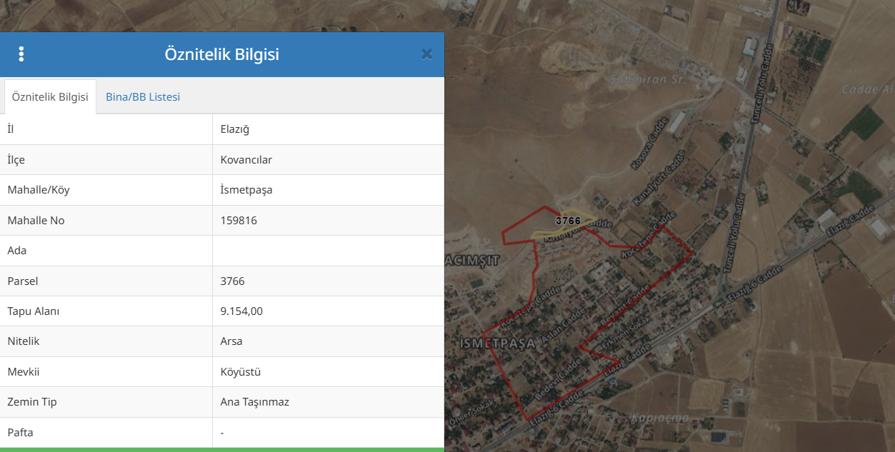

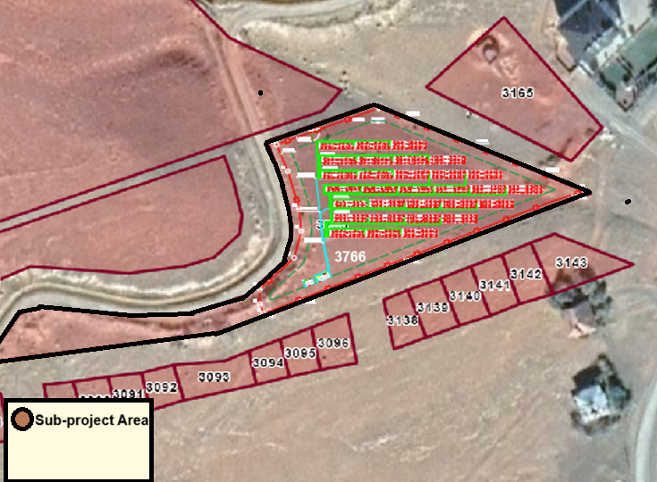

ETL Map

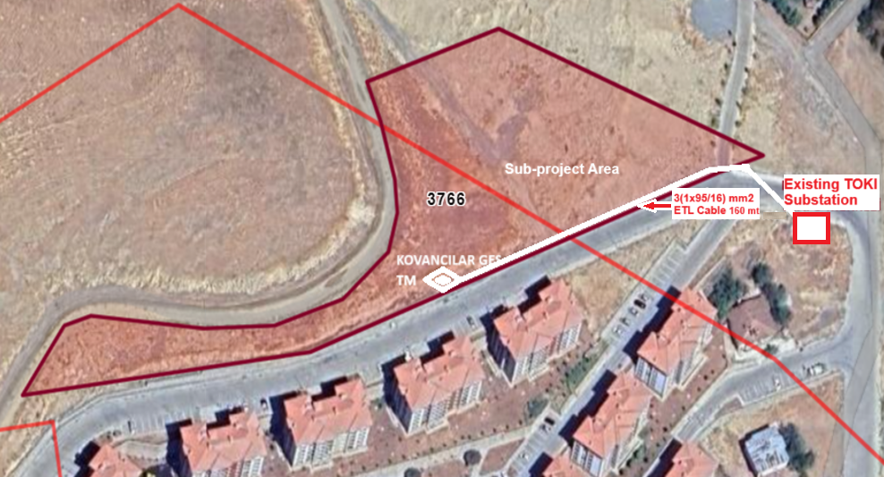

Access Road to Sub-project Area
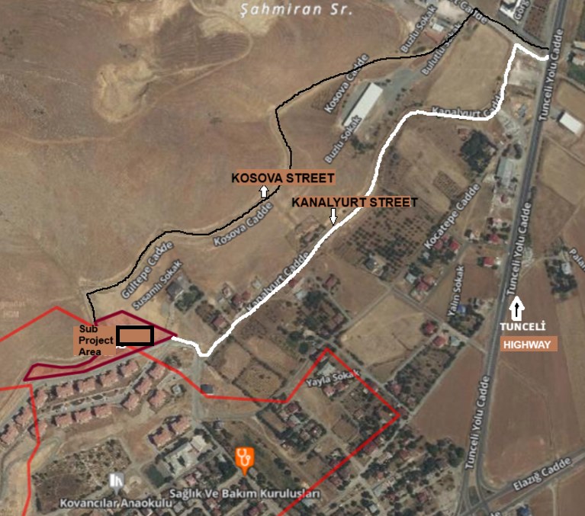

Annex-2. Copies of Existing Permitting Documentation

EIA Out of Scope Letter
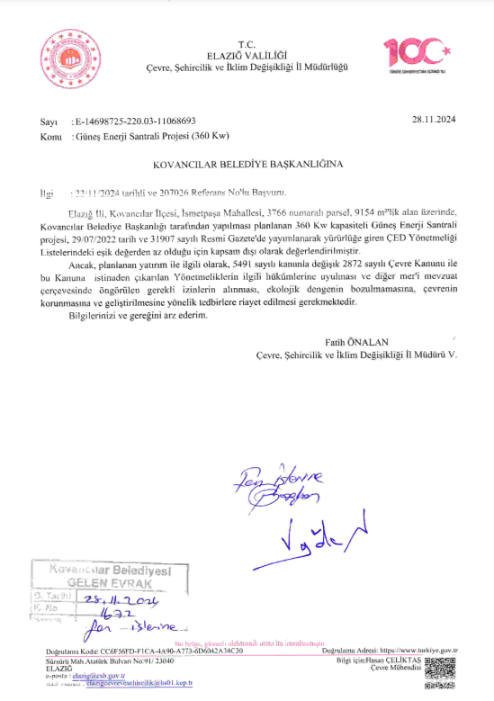

Call Letter
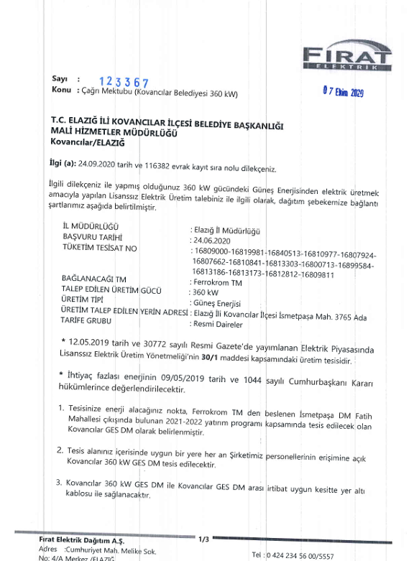

Zoning Permit Certificate
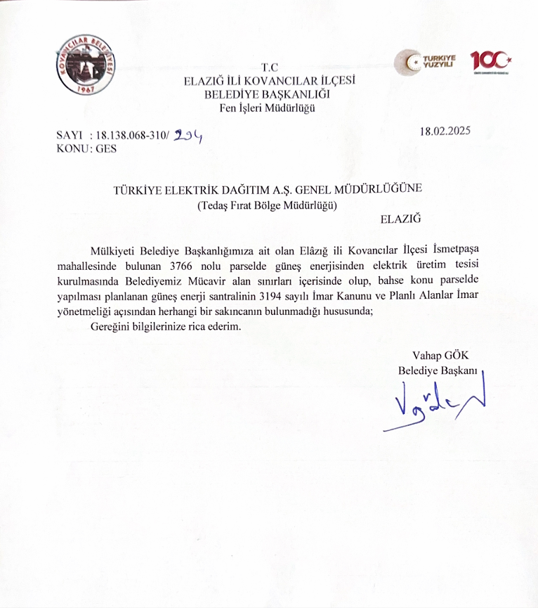

Geotechnical Survey Report
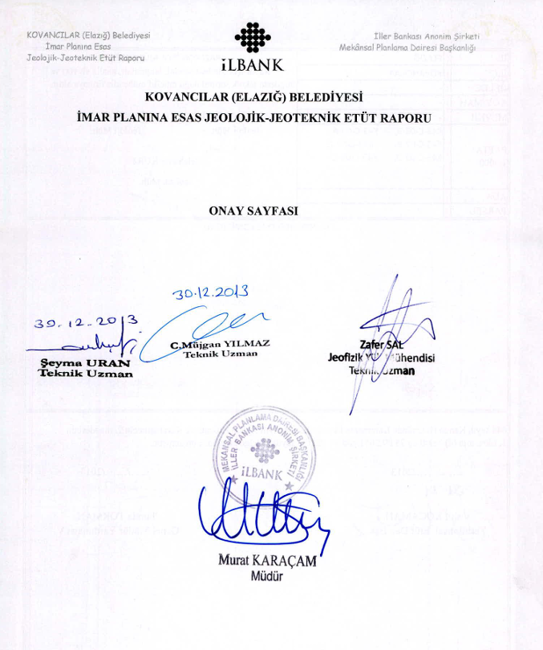

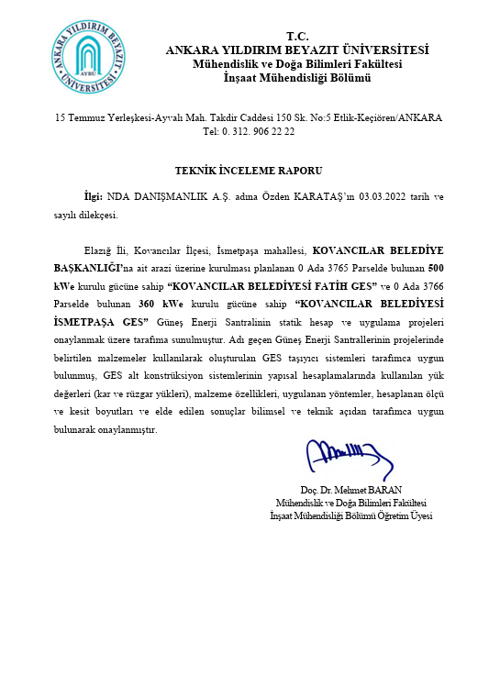

Annex-3. Copies of Title Deed(s)
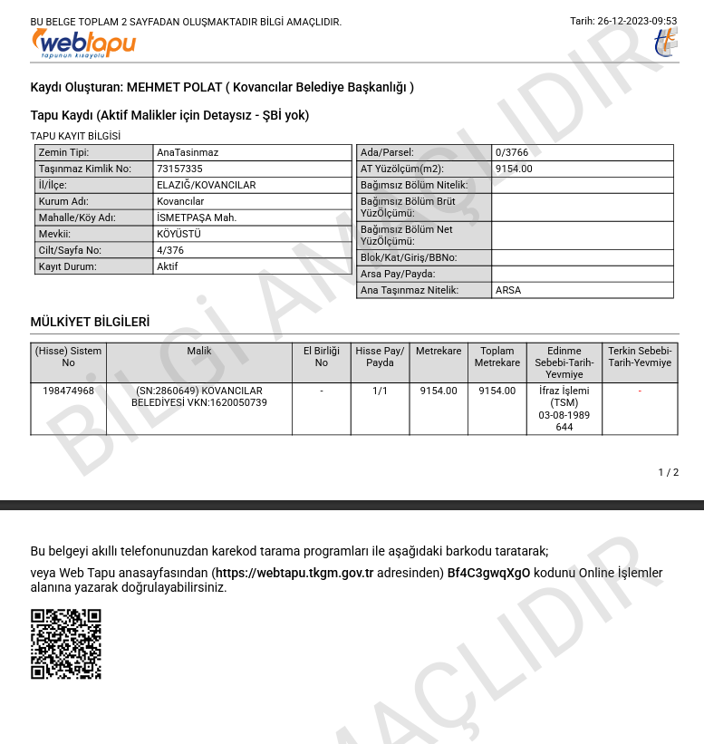

Annex-4. Sub project Area Photographic
Photo No: 01 | 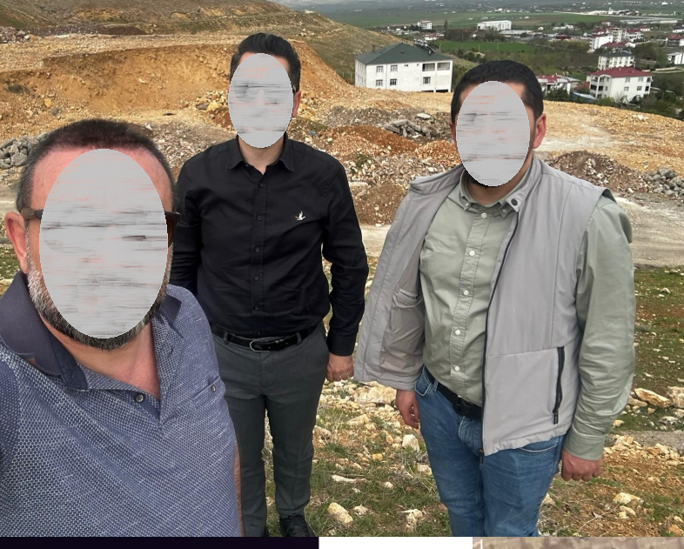
Date:13.01.2025

Location: Lot 3766 of block 0

Details/Notes:

Photo No: 02 | 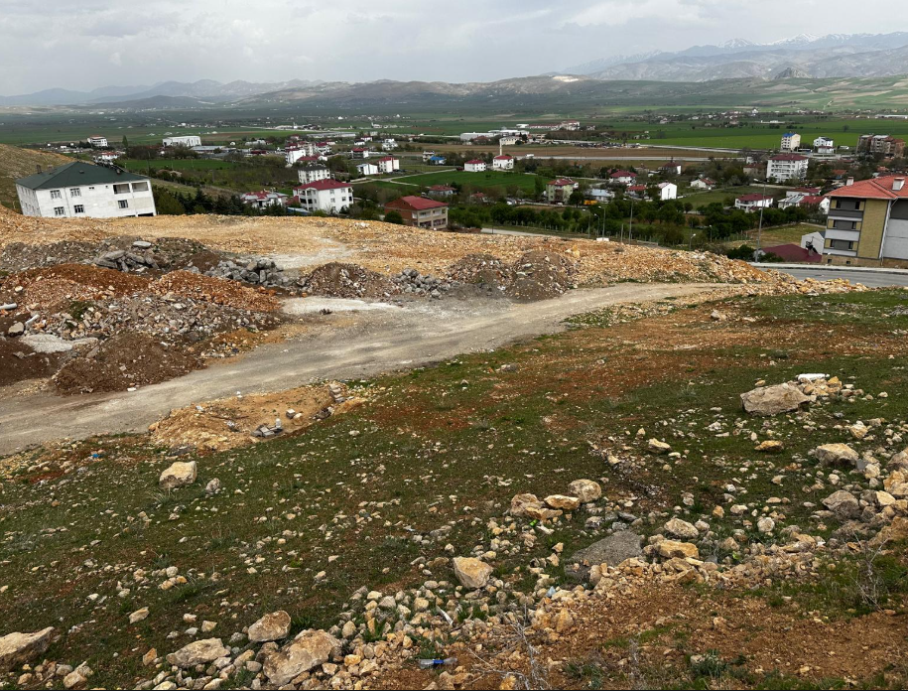
Date: 13.01.2025

Location: Lot 3766 of block 0

Details/Notes:

Photo No: 03 | 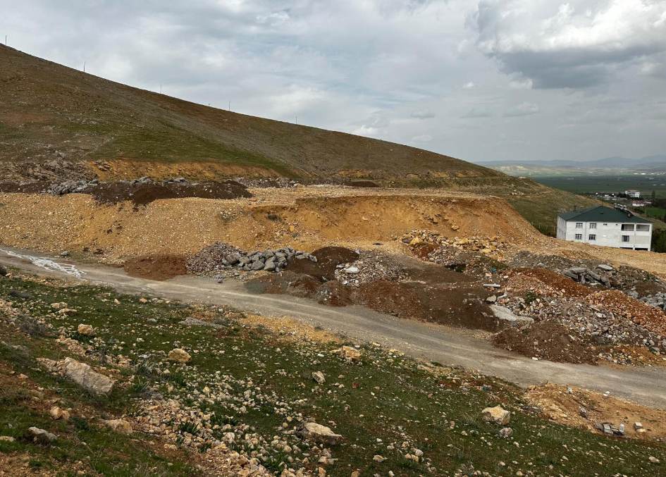
Date: 13.01.2025

Location: Lot 3766 of block 0

Details/Notes:

Photo No: 04 | 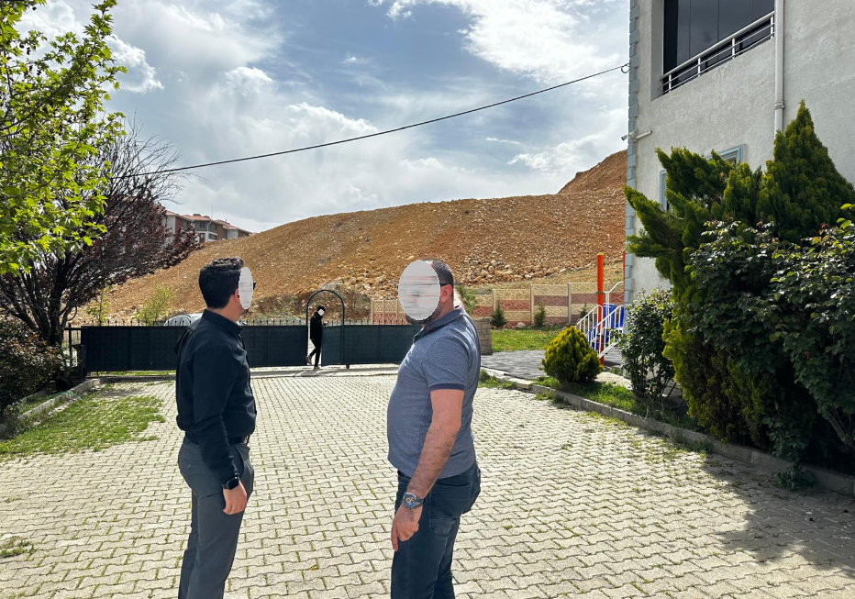
Date: 13.01.2025

Location: Lot 3766 of block 0

Details/Notes:

Annex-5. Construction Notice Template
“Çevreye verdiğimiz rahatsızlıktan dolayı özür dileriz!”

KOVANCILAR BELEDİYESİ
436 kWp/360kWe GES ALTPROJESİ YAPIM İŞİ
İşin Süresi:

Şikâyet, istek, soru ve yorumlarınız için:

YÜKLENİCİ ADI | : |  | Adres:  Telefon:  E-posta:  İletişim Formu:
İŞVEREN | : |  | Adres:  Telefon:  E-posta:  İletişim Formu:
İller Bankası A.Ş.  (İLBANK) |  |  | Adres: İller Bankası A.Ş. Emniyet Mahallesi, Hipodrom Caddesi No:9/21, Yenimahalle/ANKARA  Telefon: 0 (312) 508 79 79  E-posta: bilgiuidb@ilbank.gov.tr  İletişim Formu: https://www.ilbank.gov.tr/form/bilgiedinmeuluslararasi | 

Annex-6. E&S Incident Notification Form

1) Incident Details

Date of Incident: [Please insert] | Time of Incident: [Please insert]
Location of the Incident: | [Please insert]
Sub-borrower Name: | [Please insert]
Date Reported to ILBANK:  [Please insert] | Reported to ILBANK by:  [Please insert] | Notification Method:  [Please insert]
Date Reported to WB:  [Please indicate] | Reported to WB by:  [Please insert] | Notification Type:  [Please insert]
Contractor Name: | [Please insert]
Sub-contractor name  (please indicate if involved in the incident): | [Please insert]
2) Type of incident (please check all that apply)

☐ Fatality  ☐ Lost time injury  ☐ Child labor  ☐ Forced labor | ☐ Environmental pollution incident  ☐ Disease outbreaks  ☐ Acts of violence/protest  ☐ Other
3) Description/Narrative of Incident
4) Actions taken to contain the incident
For incidents involving a Contractor:
Name of Contractor: _______________________
Have the works been suspended? Yes ☐ No ☐
5) What support has been provided to affected people
[Please briefly describe]

6) Please provide the supporting documents for the incident, victims and involved persons
(e.g. copies of the social security registration records, victim and witness statements, notification to authorities, legal investigation reports, training records, photographs, etc.)

Annex-7. Simplified Labor Management Procedure

Annex-8. Roles and Responsibilities
Party | Role | Key Responsibilities
Sub-borrower
Sub-borrower | Sub-borrower Management | - Hold ultimate responsibility for the E&S performance of the subproject to the satisfaction of the ILBANK, including the performance of subproject contractors throughout the sub-financing agreement life cycle.  - Establish Project Implementation Unit (PIU) following the execution of sub-financing agreements to carry out operational and administrative tasks to oversee the implementation of the E&S instruments and monitoring progress; allocate resources for the recruitment of in-house environmental, social and OHS staff under the PIU  - Ensure that E&S instruments and procedures required by ILBANK is prepared within the timeframes agreed with ILBANK and allocate adequate financial and human resources – either from the Sub-borrower’s own resources or from the Subproject loan and implement.  - Cooperate with the ILBANK representatives to discuss and agree on the ESAP and other E&S covenants for incorporation into sub-financing agreements to be executed between the ILBANK and the sub-borrower (with support from RD E&S team as necessary)  - Ensure that EHSS requirements of ILBANK are incorporated into relevant contractor tender and agreement documents to be prepared in collaboration with the construction supervision consultant  - Hold and use the authority and responsibility to stop any subproject related work activity if it poses an imminent danger to health, safety, or the environment.  - Allocate resource to ensure monitoring of subproject E&S performance and reporting to ILBANK at IFI standards in line with the sub-financing agreement conditions  - Facilitate monitoring visits and audits by ILBANK and their consultants  - Notify the ILBANK RD – E&S Teams of any significant E&S incident or accident within maximum 24 hours of the accident/incident; contractually require the supervision consultants and/or contractors to promptly report such incident and accidents (timeframe to be defined by ILBANK)  - Prepare and submit a detailed E&S Incident Investigation Form, supplemented by an RCA to be conducted pursuant to GIIPs, to ILBANK within 15 days of the accident/incident date for significant accidents or incidents (in line with the template presented in the E&S Supervision, Monitoring and Reporting Procedure). The investigation will be supplemented by a Root Cause Analysis (RCA).  - Prepare and submit semiannual E&S monitoring reports to ILBANK.
Sub-borrower | E&S Team  - Environmental staff  - Social staff  - OHS staff | - Participate in the training to be organized by ILBANK as part of ILBANK ESMS Training Procedure implementation  - Ensure that E&S documentation required by ILBANK is prepared by qualified independent specialists and submitted to ILBANK for appraisal and credit.  - Provide ILBANK with relevant adequate information to undertake the E&S due diligence in accordance with the ESMS (e.g. duly completed sub-borrower questionnaire and supporting documentation to be requested by ILBANK in accordance with the E&S Screening and Risk Classification and ESDD procedures)  - Support the sub-borrower management as required in the review and evaluation of ESAP and other E&S covenants for incorporation into sub-financing agreements to be executed between the ILBANK and the sub-borrower  - Ensure compliance of subprojects operations (including contractor activities on site) with national legislation and E&S requirements of the lending WB as included in the sub-financing agreements, ESAP and subproject-specific E&S documentation.  - Undertake monitoring of subproject E&S performance and reporting to ILBANK at WB standards in line with the sub-financing agreement conditions  - Ensure implementation of corrective actions in case of E&S non-compliances in coordination and agreement with ILBANK DG and RD E&S teams over reasonable timeframes  - Coordinate the construction supervision consultants, contractors and/or external E&S consultants for collection of the monitoring data and compilation of or providing input to periodic monitoring reports as necessary and appropriate  - Allow ILBANK representatives (including individual consultants) to access subproject facilities and records
Construction Supervision Consultants (“Müsavir”) | Management and E&S staff | Carry out the following tasks on behalf of the sub-borrowers:  - Participate in the training sessions to be organized by sub-borrowers in line with the requirements of ILBANK ESMS Training Procedure  - Supervise the construction works of contractors on-site, including implementation of subproject-specific E&S requirements by contractors on a daily basis  - Ensure sufficient E&S capacity for implementation of E&S requirements as set out in the sub-financing agreements between the sub-borrower and ILBANK  - Support the sub-borrowers for the supervision and review of E&S management documentation prepared by construction contractors and submit them to sub-borrowers upon finalization  - Review monthly self-monitoring reports prepared by the construction contractors for early identification of E&S issues and/or non-compliances and submit them to municipalities/municipal utilities upon finalization  - Prepare and submit regular monthly reports to Sub-borrower on the environmental, social and OHS issues of the Sub-Project during the construction phase  - Identify E&S non-compliances on site and enforce construction contractors to undertake corrective actions within defined and agreed timeframes  - Support the sub-borrowers (as requested) in the preparation of periodic E&S monitoring reports to be submitted to ILBANK in line with the ILBANK E&S Supervision, Monitoring and Reporting Procedure  - Notify the sub-borrower of any significant E&S incident or accident that have taken place in subproject related operations within 24 hours.
Construction Contractor | Management and E&S staff | - Ensure sufficient E&S capacity for implementation of E&S requirements as set out in the construction contracts  - Participate in the training sessions to be organized by sub-borrowers in line with the requirements of ILBANK ESMS Training Procedure  - Prepare subproject-specific E&S management plans and procedures prior to start of construction works as required by the construction contracts  - Comply with the requirements of national legislation and implement the E&S requirements as set out in the sub-financing agreements (executed between ILBANK and the sub-borrowers) and construction contracts  - Submit periodic (in frequencies to be set by ESAP) E&S self-monitoring reports to the municipalities/municipal utilities through construction supervision consultants (“müşavir”) – in line with the format provided by ILBANK.  - Fill in monthly occupational health and safety (OHS) forms – reviewed by construction supervision consultants.  - Implement corrective actions in case of E&S non-compliances under the supervision of sub-borrower’s construction supervision consultant  - Promptly notify the sub-borrower of any significant E&S incident or accident that have taken place in subproject related operations (timeframe to be defined by ILBANK no later than 24 hours).

Annex-9. Chance Find Procedure
Introduction
This document describes the Chance Find Procedure for subproject, outlining the procedures that will be followed in case of chance finds occur during the construction activities associated with the subproject.
Scope
This Chance Find Procedure (CFP) will be implemented for Municipality Kovancılar sub-project in order to manage any chance finds that may be encountered during the construction activities. The purpose of the CFP document is to:
- outline the applicable legislation and standards relevant to this procedure;
- define roles and responsibilities;
- define project commitments, operational procedures, training requirements and guidance relevant to this procedure; and
- define monitoring and reporting procedures.
Although there are no known archaeological sites or remains within the subproject area, it is considered that there may be a potential to encounter archaeological findings during the construction of the subproject. Activities which have high potential to lead to discover or adversely affect the archeological resources are;
- topsoil stripping
- excavation and earthworks
This CFP is prepared in order to provide information to the contractors and employees regarding the actions to be taken in case of an archaeological chance find discovery.
Legislation and Standards
Legislation and standards that apply to the project comprise the following:
- Word Bank Environmental and Social Standard (ESS) 8: Cultural Heritage
- applicable Turkish laws and national standards
- other commitments to and requirements of Turkish government authorities
- other industry guidelines with which the project has committed to comply
In Turkey, movable and immovable cultural and natural assets are protected and preserved by the Law on Preservation of Cultural and Natural Assets (Law No. 2863) published in the Official Gazette dated 23.07.1983 and numbered 18113. Law 2863 establishes legal protection for the following:
- all natural assets and immovable cultural assets constructed up until the end of the 19th century,
- any immovable cultural asset from after the end of the 19th century, identified by the Ministry of Culture and Tourism as an important asset worthy of preservation,
- all immoveable cultural assets located within archeological sites,
- buildings/areas that have witnessed significant historical events during the National War and the foundation of the Turkish Republic and dwellings that have been used by Mustafa Kemal ATATÜRK, regardless of time and registration.
The Ministry of Culture and Tourism is the responsible body to take decisions for protection of cultural heritage in Turkey at the national level. As part of the Ministry, the High Commission for the Protection of Cultural Assets is responsible for protecting and restoring immovable cultural assets. Implementation of the decisions and regulations issued by the Ministry are undertaken by local administrations. At local level, there are Cultural Assets Protection Regional Boards defined by the Ministry of Culture and Tourism, which are responsible for preservation, registration and classification of cultural heritage within their respective jurisdictions. The relevant Regional Board for the project is the Diyarbakır Cultural Heritage Protection Regional Board Directorate.” According to Law 2863, all the natural and cultural assets qualified for legal preservation are properties of the State. Therefore, regional boards have the power and authority to provide legal protection to the preservation sites and to approve or reject all the activities, which have potential negative impacts on the preservation sites such as construction, demolition and excavation activities.
Roles and Responsibilities
Principal roles and responsibilities for the implementation of this procedure are outlined below.
Role | Responsibilities
Contractor -Project Manager | - Overall responsibility for the development, review, approval and coordination of the numerous activities required to initiate, conduct and complete construction.  - Ensure that this procedure is prepared, and updated as required, based on the activities undertaken as part of the project.  - Ensure that adequate resources are made available to implement the procedures and guidelines outlined in this procedure.
Contractor -Environmental and Social (E&S) Expert | - Initiation, development, implementation and coordination of the CFP during construction.  - Ensure that adequate training is given to all site personnel and sub- contractors, covering the procedures and guidelines outlined in this procedure. Establish appropriate control procedures and conduct audits as necessary.  - Consultation with and reporting to relevant government bodies in case of potential archeological chance finds.  - Record all confirmed chance finds by filling up the “Chance Find Reporting Form” and maintain copies in a log-book. Ensure that the chance finds log-book is up to date.
Contractor - Site Manager | - Day-to-day implementation of the provisions of the CFP in the field during construction.  - Notify the E&S Expert regarding potential chance finds during construction.
Employees | - Understand and comply with archeological chance finds procedures and guidelines outlined in this procedure.  - Reporting of the potential chance finds to the Site Manager.

Impact Avoidance and Mitigation
In the event of an archaeological discovery, the following actions will be implemented:
- All staff involved in land clearance and excavation activities will take the responsibility for managing archaeological protection and will be trained in these aspects by the E&S Expert.
- In case any potential chance find is encountered, all construction activities will cease immediately in the vicinity of the chance find.
- The Site Manager will be contacted immediately. The discovered site location, the characteristics of the potential archaeological material and photos will be recorded by the Site Manager, who in turn will inform the E&S Expert.
- Elazığ Museum Directorate will be notified at the latest within three days after the chance find is encountered. Contact details of the Elazığ Museum Directorate are given below:
Address: Sürsürü Mahallesi Atatürk Bulvarı Nurettin Ardıçoğlu Kültür Merkezi No:79 / ELAZIĞ
Telephone: (0424) 241 11 30
E-mail: elazigmuzesi@kultur.gov.tr
- The site and its vicinity will be secured 24 hours a day against damage or loss, until inspection by the authority.
- The E&S Expert will fill up a “Chance Find Report Form” for each confirmed chance find and inform the Project Manager about the date that the construction work can resume, which is determined by the authorities concerning the conservation of the heritage.
- Further steps to be followed and proper plan to be implemented for the management of the finds (Changes in the layout, conservation, preservation, restoration and salvage) will be decided and reported in writing by the authorities in charge.
- Photographs of the potential artifacts that are likely to be encountered in the construction site are presented in the following pages to be used during the training of the relevant staff.

Verification and Monitoring
E&S Expert/s will record all cases of archaeological chance finds. He/she will fill up a “Chance Find Reporting Form” for each chance find confirmed by the authority and maintain copies in a logbook. A sample of a reporting form which can be used to record chance finds is included below. The chance find logbook will be summarized on an annual basis and records included in semi-annual monitoring reports to verify that correct management procedures have been followed. Action items will be taken in cases of non-adherence to this CFP.

Reporting
Contractor will comply with reporting requirements including chance finds defined in site-specific ESMP (contractor will develop monthly and quarterly monitoring reports and submit to Kovancılar Municipality through supervision consultant; Kovancılar Municipality will examine submit the reports to ILBANK quarterly (and monthly if requested by ILBANK); ILBANK will inform the World Bank by providing regular semi-annual monitoring reports.

Kovancılar Municipality Subproject
Chance Find Reporting Form
REGISTRATION
Name of recorder:
Date and time of discovery:
Site Name: | Coordinates  X Y
Description of find:
Photograph:
Estimated weight and dimensions:
CONTACT PERSON
Name/Title/Duty:
Date and Time:
Contact information:
Details of conversation:
DECISIONS
Any protection measures to be implemented:
Movable or immovable: If moved, please specify the new location.
Further actions required:
Recommence date and time:
Notes:
SUBMISSION
Name: |  | Date:

Annex-10. Change Notification Form
Change Notification Form
Subproject Name
Subproject Location
Subproject Phase | ☐ | Pre-construction
Subproject Phase | ☐ | Construction
Subproject Phase | ☐ | Operation
Name of the Institution Notifying the Change
Date
Category of the Change  (please select all that apply) | ☐ | Legislative Change
Category of the Change  (please select all that apply) | ☐ | Design Change
Category of the Change  (please select all that apply) | ☐ | Schedule Change due to E&S factors
Category of the Change  (please select all that apply) | ☐ | Project Schedule Changes due to technical, financial, legal or administrative factors
Category of the Change  (please select all that apply) | ☐ | Changes due to E&S issues encountered at subproject implementation
Category of the Change  (please select all that apply) | ☐ | Contractor or Construction Supervision Consultant Change
Category of the Change  (please select all that apply) | ☐ | Other (please specify below)
Detailed Description of the Change(s)

Documents Submitted with Change Notification Form

Name of the Staff Notifying the Change

Position of the Staff Notifying the Change

Signature

Annex-11. Stakeholder Consultation Meeting
TURKIYE PUBLIC AND MUNICIPAL RENEWABLE ENERGY PROJECT
(PUMREP)

KOVANCILAR MUNICIPALITY
436 kWp/360 kWe
SOLAR POWER PLANT PROJECT
MINUTES OF STAKEHOLDER CONSULTATION MEETING

Delivery Date  Meeting Date  Meeting Location | :  :  : | August 22, 2025  August 19, 2025  Kovancılar Municipality Conference Hall

- STAKEHOLDER CONSULTATION MEETING
The Kovancılar Municipality 436 kWp/360 kWe Solar Power Plant Project (hereinafter referred to as the "subproject"). The Kovancılar Solar Power Plant Project, planned to be implemented within the scope of the KABYEP (Capital Project Development Plan), is located on lot 3766 block 0, in the İsmetpaşa neighborhood of Kovancılar district, Elazığ province. It aims to support the Kovancılar Municipality in meeting its carbon emission reduction commitments, improving energy security, and expanding the use of renewable energy. The subproject will be financed through the following relevant subcomponents.
An Environmental and Social Management Plan (ESMP) Checklist and a Stakeholder Engagement Plan (SEP) were prepared as part of the project. In addition to these efforts, a Stakeholder Consultation Meeting was held on August 19, 2025, at 2:00 PM, following the completion of the ESMP Checklist. Meeting announcements were published on the Kovancılar Municipality's official website and in national and local newspapers, and the public was informed through brochures posted on neighborhood headmen's offices and bulletin boards.

1.1 Summary
As part of the Public Participation Meeting, representatives from the Kovancılar Municipality and the company that prepared the documents provided information about the sub-project.
Kovancılar Municipality announced the meeting to the İsmetpaşa neighborhood within the project's impact area, including citizens, relevant civil society organizations, and local media representatives.
The Public Participation Meeting was held with the participation of 20 people, including the İsmetpaşa neighborhood headman, İsmetpaşa residents, citizens, and Kovancılar Municipality staff, and lasted one hour in total.
The meeting began with an opening speech by the Mayor of Kovancılar. Information was provided about the subproject process. Following this, the PVGLOBAL Energy project manager gave a presentation detailing the subproject's Environmental and Social Management Plan (ESMP) Checklist and Stakeholder Engagement Plan (SEP). The ESMP outlined the subproject's topic, stakeholders, environmental and social risks, and mitigation measures.
It was also stated that the grievance mechanism would be prioritized and effectively implemented throughout the construction and operation phases of the subproject.
Then, a question-and-answer session was held. The questions were answered by the PVGLOBAL Energy project manager.

1.2 Question & Answer Session
Question 1: Is there a fire risk at the solar power plant? What are the precautions? (İsmetpaşa Neighborhood Mukhtar)
Answer 1: All fire precautions will be taken in accordance with legislation and standards. Employees will be trained on the Fire Emergency Response Plan. A sufficient number of fire extinguishers will be available at various points throughout the plant. (Project Manager)
Question 2: Will the solar power plant project cause environmental pollution? (Citizen)
Answer 2: All precautions will be taken to prevent environmental pollution caused by workers at solar power plants, especially during the construction phase. Actions will be taken in accordance with management plans, procedures, and applicable legislation, and mitigation measures will be implemented. No negative impacts are expected. (Project Manager)

Question 3: Does the solar power plant have a negative impact on human health? (Kovancılar Municipality employee)
Answer 3: There is no scientific data indicating that the solar power plant is harmful to human health. However, broken or waste panels will be stored in closed, leak-proof containers in a temporary storage area on the construction site. The waste panels will then be transferred to licensed recycling facilities. Furthermore, because the subproject is located far from the residential area, no negative impacts are expected. (Project Manager)
Question 4: Does the solar power plant have any negative impact on nearby residential areas? (İsmetpaşa Neighborhood Resident)
Answer 4: No negative impacts are expected from the solar power plant on residential areas. Mitigation measures will be implemented to minimize impacts. To this end, management plans and procedures will be developed and implemented to address environmental and social impacts. There will be a grievance mechanism for the public to convey their complaints. (Project Manager)

1.3 Conclusion
At the approximately one-hour Public Participation Meeting, officials from PVGLOBAL Energy and Kovancılar Municipality provided information about the project, and a question-and-answer session was held. The public was provided with necessary information and answered questions about the 436 kWp/360 kWe solar power plant project, planned for construction on lot 3766 block 0, in the İsmetpaşa neighborhood of the Kovancılar district of Elazığ province.

- Participant List
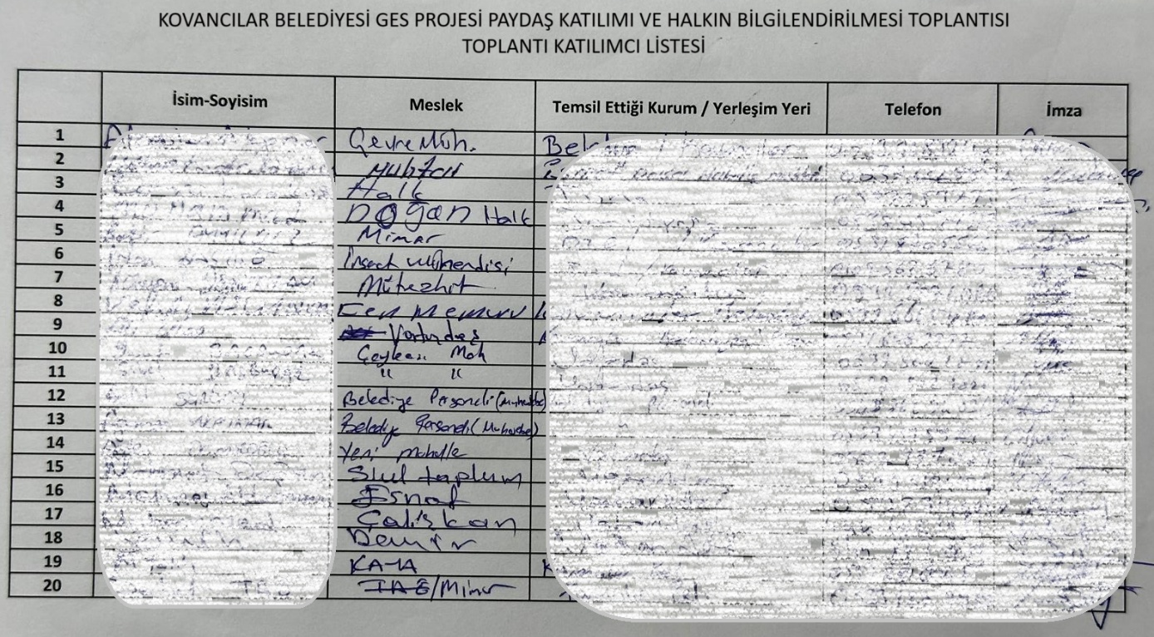

- APPENDICES

Annex 1: Stakeholder Consultation Meeting Photos

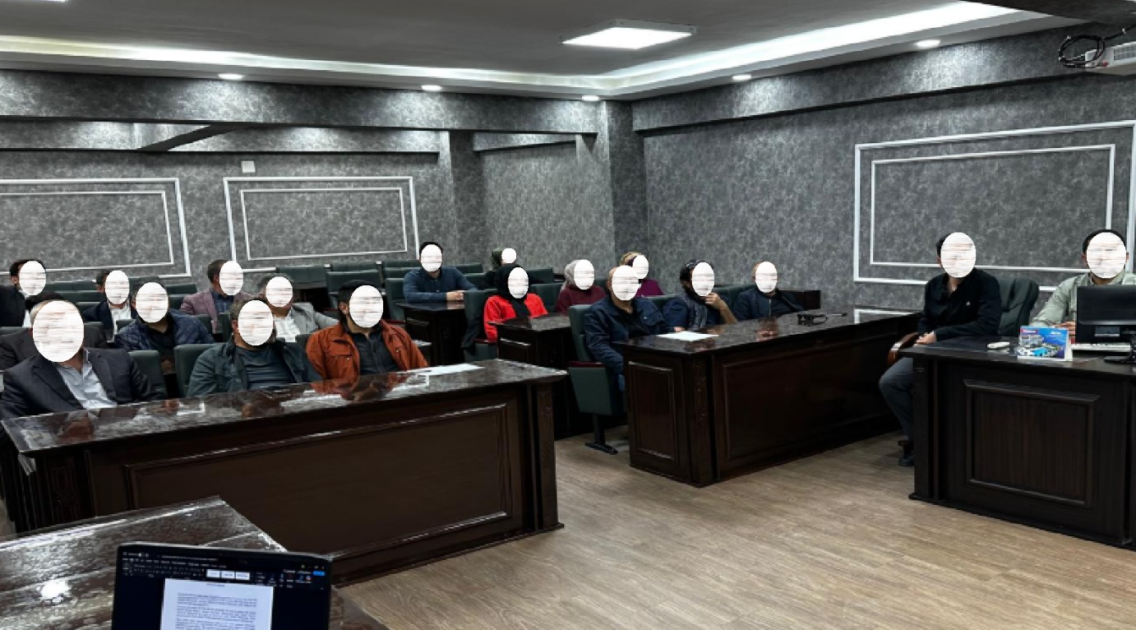
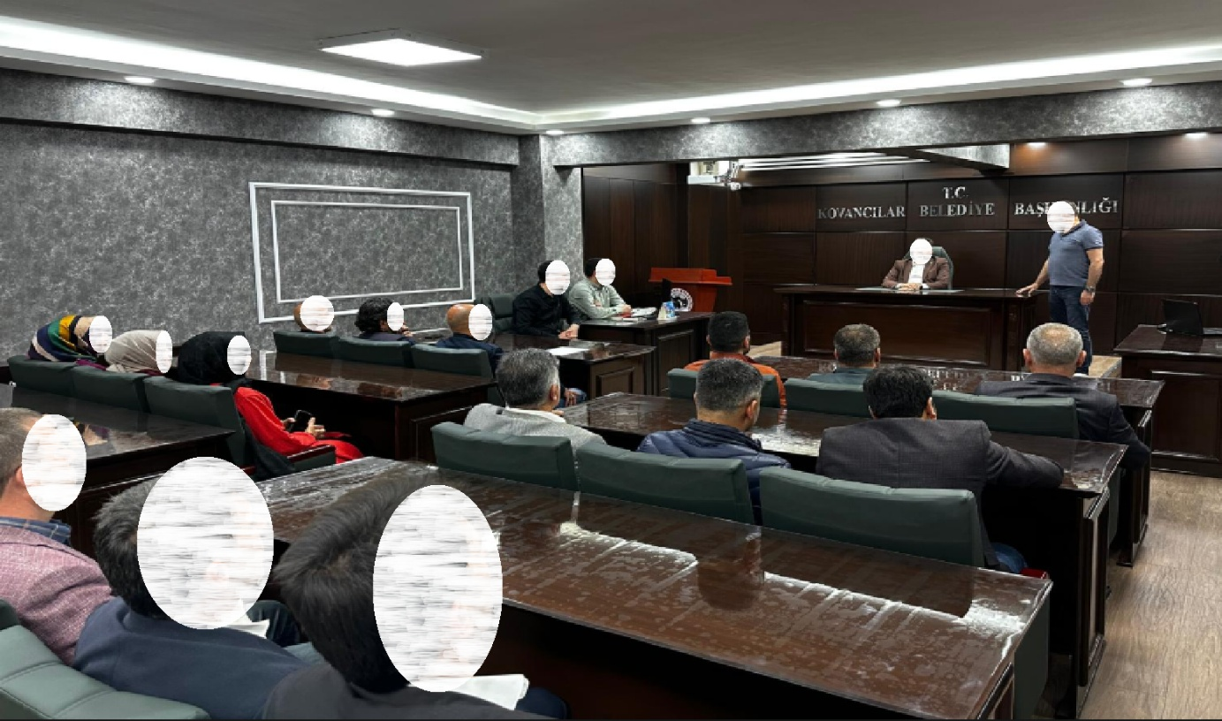

Annex 2 Newspaper Advertisements

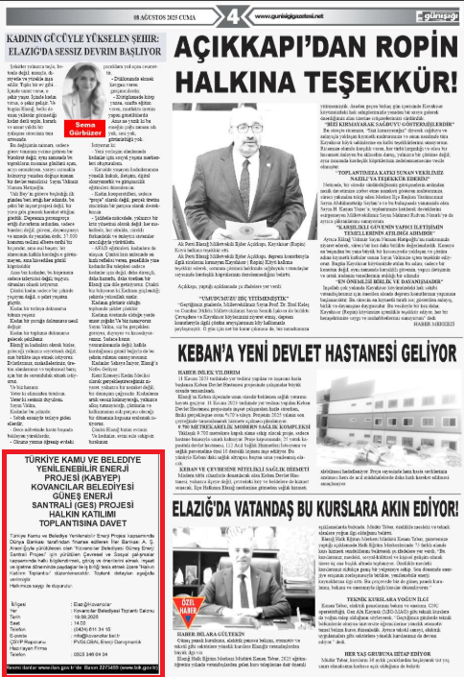
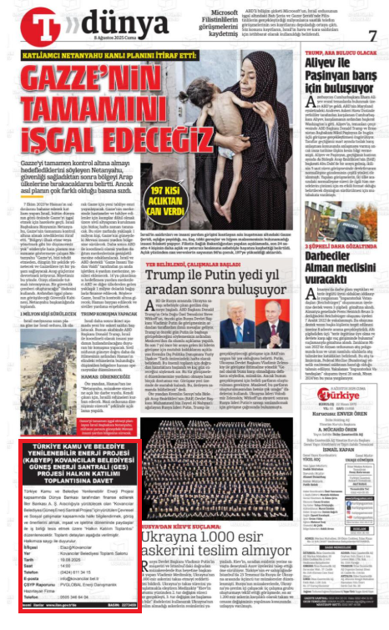

Annex 3 Brochure Distribution at the for Invitation to Stakeholder Consultation Meeting

Annex 4 Stakeholder Consultation Meeting Brochure for the Sub-Project
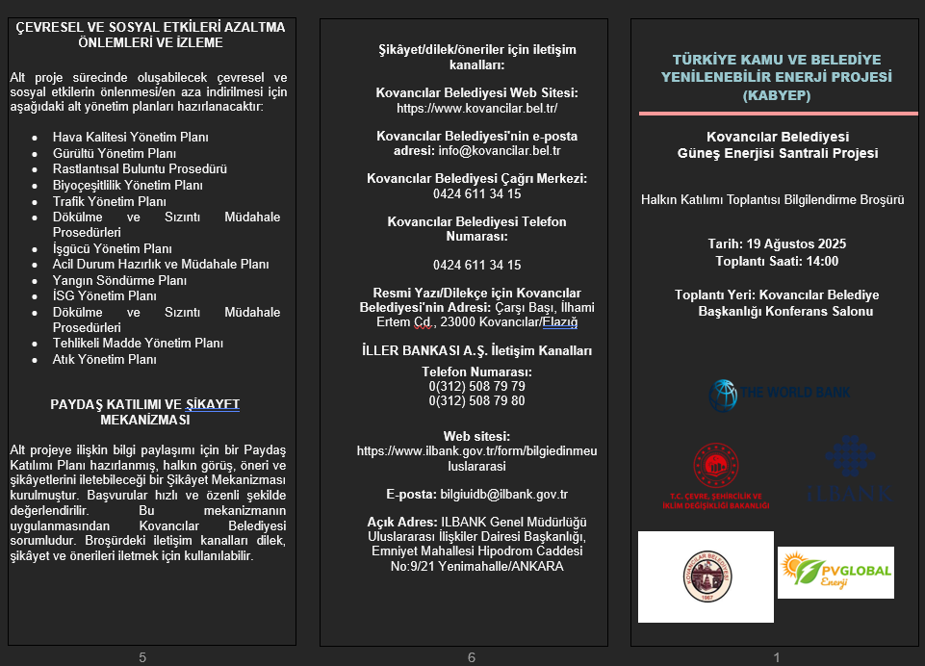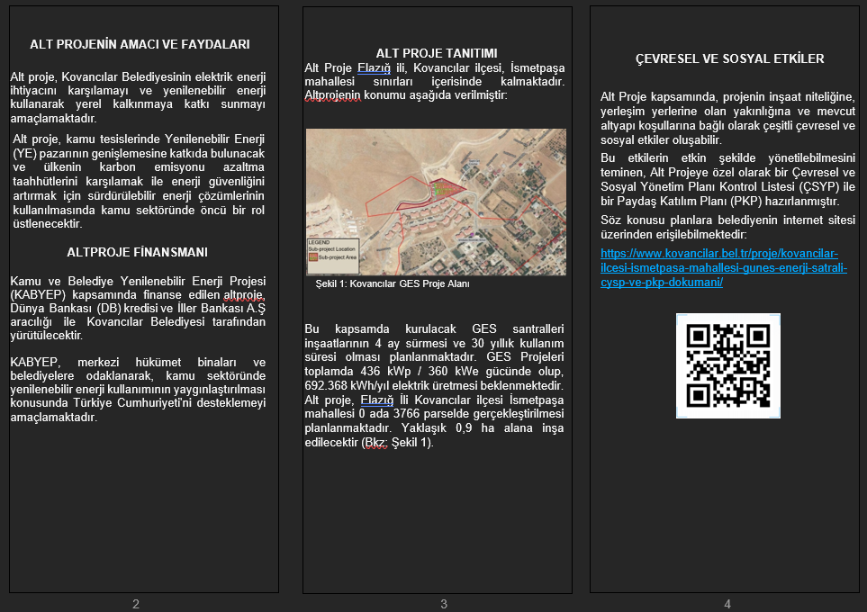

Annex 5 Screenshot of Publishing of ESMP Checklist and SEP on Elazığ Municipality Web Page
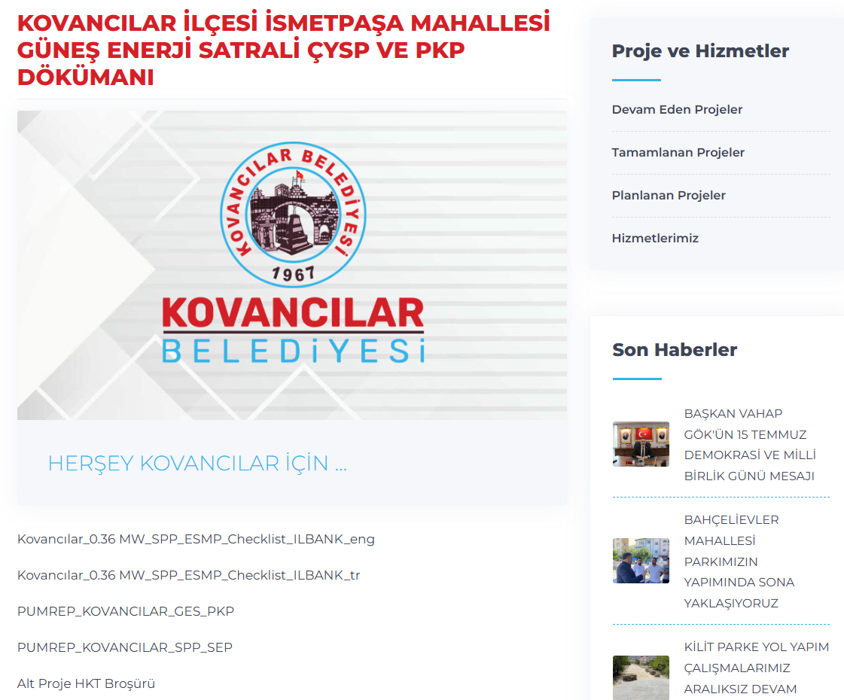

https://www.ifc.org/en/insights-reports/2000/general-environmental-health-and-safety-guidelines
https://www.ilbank.gov.tr/userfiles/files/Grievance_Mechanism.pdf
Sensitive complaints could include the following (not an exhaustive list): 1) Sexual exploitation and/or any type of abuse by a staff member; 2) Fraud and/or corruption by a staff member, such as involvement in bribery or misusing funds; 3) Any action which constitutes a breach of ILBANK code of conduct including staff behavior..
Any incident or accident relating to the subproject which has, or is likely to have, a significant adverse impact on the environment and/or health and safety of communities or employees (direct or contracted) involved in the subprojects related operations will be considered significant, including, inter alia, chemical and/or hydrocarbon materials spills; fire, explosion or unplanned releases, including during transportation; ecological damage/destruction; traffic or other type of accidents that could result in fatalities or serious injuries affecting employees and/or public complaint or protest; failure of emissions or effluent treatment; legal/administrative notice of violation; penalties, fines, or increase in pollution charges; negative media attention; chance cultural finds; labor unrest or disputes; local community concerns.
In compliance with the Personal Data Protection Law, the meeting participant list is not published and is stored in the Project Implementation Unit's archives solely for sub-project management purposes. It will be retained for the duration of the sub-project and will not be shared with third parties.

